LABORATORY MANUAL
Ultrasonic Distance
Measurement Trainer
PIC16F887 · 40 kHz transmit and receive pair · HC-SR04 measurement principle
Working principle, stage-by-stage test procedure, calibration and student experiments
Institution
Department
Subject / laboratory code
Student name
Roll number
Batch / section
Date of experiment
Faculty in charge

This manual describes the hardware in main.pdf (three schematic sheets) and the firmware in Ultrasound.c and flex_lcd.c.
Revision 1.0

Contents
1. About this board 4
1.1 What it is 4
1.2 What you should be able to do after this experiment 4
1.3 Equipment required 4
1.4 Safety and handling 4
2. The measurement principle 6
2.1 Echo ranging 6
2.2 Why the answer is 'time divided by 58' 6
2.3 The speed of sound is not a constant 6
2.4 Why 40 kHz, and why a burst 7
2.5 What sets the minimum and the maximum range 7
2.6 How this trainer differs from a sealed HC-SR04 module 7
3. System overview 9
3.1 Block diagram 9
3.2 One measurement, step by step 9
3.3 Connectors, controls and test points 9
4. Circuit description, stage by stage 11
4.1 Stage 0 - Power supply 11
4.2 Stage 1 - Microcontroller core, clock and reset 11
4.3 Stage 2 - The 40 kHz transmitter 12
4.4 Stage 3 - Receiving transducer and pre-amplifier (U6) 12
4.5 Stage 4 - The 40 kHz band-pass filter (U7) 13
4.6 Stage 5 - Threshold comparator (U5) and logic-level clamp 14
4.7 Stage 6 - Mode switch S1 14
4.8 Stage 7 - Display and serial output 14
5. How the firmware works 16
5.1 Files and building 16
5.2 Generating the carrier, and why it is polled 16
5.3 One ranging cycle 17
5.4 Turning ticks into centimetres 18
5.5 The two failure reports 18
5.6 The display and the serial stream 19
5.7 The three constants you may need to change 19
6. Stage-by-stage testing 20
6.0 Before power is applied 20
6.1 Summary of what you should see 20
Test 1 - Supply rails 20
Test 2 - The microcontroller is alive 20
Test 3 - Mode switch and RB0 21
Test 4 - The 40 kHz transmit drive at TP2 21
Test 5 - The transmitter is actually making sound 21
Test 6 - The pre-amplifier, U6 21
Test 7 - The band-pass filter, U7 22
Test 8 - Setting the threshold on VR1 22
Test 9 - The echo logic at TP3 22
Test 10 - End to end 22
7. Calibration 23
7.1 The threshold, VR1 23
7.2 The blanking time, BLANK_TIME_US 23
7.3 The fixed offset, ECHO_OFFSET_TICKS 23
7.4 Calibration record 24
8. Experiments 25
Experiment 1 - The 40 kHz carrier and the transmit burst 25
Experiment 2 - Gain of the receive chain 27
Experiment 3 - Verifying the time-of-flight relationship 28
Experiment 4 - Accuracy, linearity and repeatability of the display 30
Experiment 5 - The blind zone and the blanking time 31
Experiment 6 - Maximum range: target size, material and angle 32
Experiment 7 (extension) - Beam width 33
Experiment 8 (extension) - Serial logging and the temperature correction 33
9. Troubleshooting 34
10. Review and viva questions 35
11. Notes for the instructor and the board maintainer 36
Appendix A - Pin-out and connector reference 37
Appendix B - Parts list, grouped by stage 39
Appendix C - Firmware and formula quick reference 41
Appendix D - Bench card 42
Appendix E - Answers to the review questions 43
Appendix F - Schematic sheets 45

1. About this board

1.1 What it is
This trainer measures the distance to an object by timing an echo. It does exactly what a sealed HC-SR04 module does, except that every stage is brought out on the board so that it can be probed, measured and understood. A PIC16F887 generates a short burst of 40 kHz sound, a separate receiving transducer picks up the echo, three op-amp stages amplify and shape it, a comparator turns it into a logic level, and the microcontroller times the interval and puts the answer on a 20 x 4 LCD and on a serial port.
The board carries five test points, TP1 to TP5, placed so that a student can follow one ping from the microcontroller pin, out through the transmitter, back through the receiver, and into the microcontroller again. Sections 6 and 8 are built around those five points.

1.2 What you should be able to do after this experiment
- State the echo-ranging relationship d = c t / 2 and explain why the practical constant works out at 58 microseconds per centimetre.
- Explain why a 40 kHz carrier is used rather than a single click, and why the burst is eight cycles long.
- Identify each stage on the schematic, predict what should be seen at its output, and confirm it with an oscilloscope.
- Calculate the gain of an inverting amplifier and the centre frequency of a multiple-feedback band-pass filter, and verify both by measurement.
- Explain how a timer and a comparator together form a time-of-flight measurement, and calculate the resolution that a 1.6 microsecond tick gives.
- Explain what sets the minimum range (blanking) and the maximum range (echo strength), and demonstrate both.
- Fault-find the board stage by stage instead of guessing.

1.3 Equipment required
Item | Specification | Used for
Oscilloscope | Dual channel, 20 MHz or better, x10 probes | All of Section 6, and Experiments 1, 2, 3 and 5
Digital multimeter | DC volts, continuity | Supply rails, threshold setting
Bench supply / mains transformer | 12-0-12 V, 500 mA secondary | Board power (P4)
Metre scale or measuring tape | 0 to 3 m, 1 mm divisions | Target positioning
Flat target | Approx. 300 x 300 mm rigid board | All ranging experiments
Smaller targets | 100 x 100 mm board, a cylinder, a cloth-covered board | Experiment 6
Thermometer | 0 to 50 degC | Experiment 8 (speed-of-sound correction)
USB-to-TTL serial adapter | 3.3 V or 5 V logic, 38400 baud | Serial output on P1
PIC programmer and CCS compiler | PICkit or equivalent, CCS PICC 5.019+ | Section 7 calibration and Experiment 5, where firmware constants are changed and the board is reflashed

1.4 Safety and handling
- The board runs from a mains transformer. Only the low-voltage secondary should ever reach the board. Keep the mains side of the transformer fully insulated and never probe it.
- Three supply rails are present: +12 V, -12 V and +5 V. A probe slipped between the +12 V and -12 V pins of an op-amp puts 24 V across it. Power down before moving flying leads.
- Always clip the oscilloscope ground to TP1 and nowhere else. TP1 exists precisely so that the ground clip has one safe, defined home.
- The 7805 regulator (U3) drops 7 V and will get warm. Do not hold it while the board is powered.
- The transducers are ceramic. Do not press on the metal mesh face and do not solder them with more heat than necessary.
- 40 kHz is above the hearing range of most adults but not of all young people, and not of dogs. Do not leave the board in continuous-carrier mode for long periods with the transducer pointed at anyone.

2. The measurement principle

2.1 Echo ranging
Sound travels through still air at a known and fairly stable speed. If a short burst of sound is sent towards an object and the time until its echo returns is measured, the distance follows directly. The one point that catches everyone the first time is that the sound makes the journey twice - out to the target and back again - so the path length is 2d, not d.
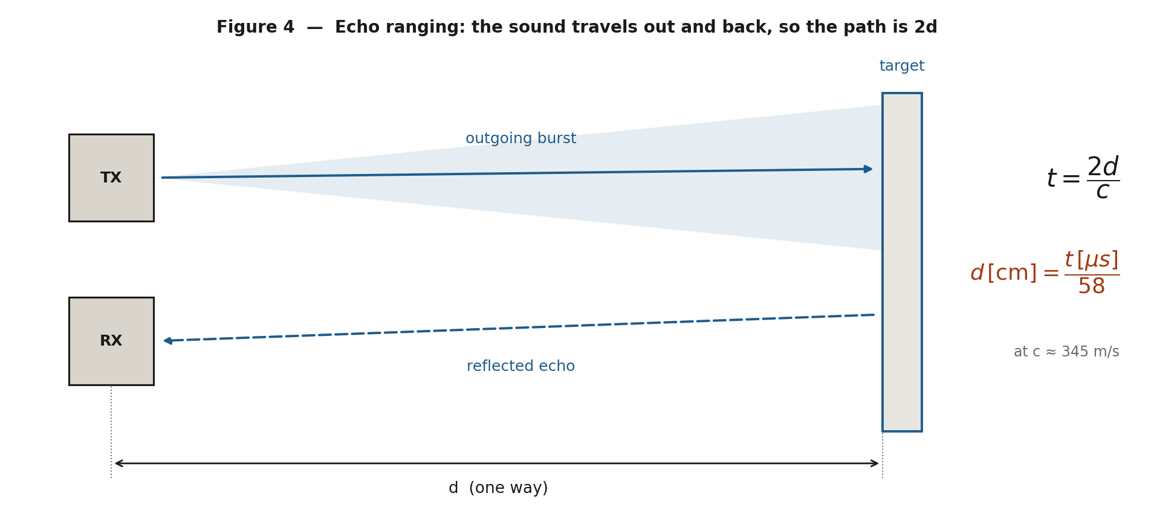
Figure 4 - Echo ranging. The measured time corresponds to twice the distance to the target.
If c is the speed of sound and t is the measured round-trip time, then
t = 2d / c and therefore d = c t / 2

2.2 Why the answer is 'time divided by 58'
Working in the units an embedded programmer actually has - microseconds and centimetres - makes the arithmetic trivial. Take c = 344.8 m/s, which is the speed of sound in dry air at about 22 degC:
c = 344.8 m/s = 34 480 cm/s = 0.034 48 cm per microsecond

d = c t / 2 = 0.034 48 x t / 2 = t / 58.0

so 1 cm of distance = 58 microseconds of round-trip time
That single number, 58, is the whole of the ranging calculation. It appears in the HC-SR04 datasheet, it appears in this board's firmware, and it is the number you will verify for yourself in Experiment 3.

2.3 The speed of sound is not a constant
The speed of sound in air depends mainly on temperature, and only very weakly on pressure and humidity. A good working approximation is
c = 331.3 + 0.606 x T (m/s, with T in degrees Celsius)
The firmware uses a fixed 58 microseconds per centimetre, so any deviation from about 22 degC shows up directly as a scale error:
Air temperature | Speed of sound | True us per cm | Error of a fixed 58 us/cm
0 degC | 331.3 m/s | 60.4 | reads about 4.1 % high
10 degC | 337.4 m/s | 59.3 | reads about 2.2 % high
22 degC | 344.6 m/s | 58.0 | correct by definition
30 degC | 349.5 m/s | 57.2 | reads about 1.4 % low
40 degC | 355.5 m/s | 56.3 | reads about 3.0 % low
Worth remembering
A 4 % error at 2 m is 8 cm. For a laboratory exercise at room temperature the fixed constant is fine, but any real product that has to hold better than a few per cent needs a temperature sensor and a corrected constant. This is a good discussion point during the viva.

2.4 Why 40 kHz, and why a burst
Three reasons drive the choice of 40 kHz:
- It is inaudible. Above roughly 20 kHz the sound does not annoy people in the room.
- The transducers are cheap and efficient. Mass-produced open-type piezo transducers are resonant at 40 kHz, so they deliver far more sound for a given drive voltage than they would at any other frequency. Their bandwidth is only a few kilohertz either side of resonance, which is why the transmit frequency must be right.
- A short wavelength gives a directional beam. At 40 kHz the wavelength is about 8.6 mm, so a transducer 16 mm across is roughly two wavelengths wide and produces a beam of perhaps 30 degrees at the -6 dB points rather than spraying sound everywhere.
A burst is used rather than a single pulse because a resonant transducer needs several cycles to build up to full amplitude. Eight cycles is the number the HC-SR04 uses, and it is a compromise: more cycles put more energy into the air and increase the range, but they also make the transmitted packet longer, which lengthens the ring-down and pushes up the minimum measurable distance.
wavelength = c / f = 344.8 / 40 320 = 8.55 mm
8 cycles = 8 / 40 320 Hz = 198.4 us = 6.8 cm of sound in air

2.5 What sets the minimum and the maximum range
Minimum range is set by the transmitter, not by the timer. While the transducer is being driven, and for a while afterwards while it rings down, the receiving side is swamped - partly by sound coupling straight across from transmitter to receiver, partly through the board and the air gap between them. The firmware therefore refuses to listen for a fixed blanking interval after each burst. Any echo that returns during that window is lost, so
minimum range in cm = BLANK_TIME_US / 58
Maximum range is set by how much echo survives the journey. Sound spreads out, so the returning intensity falls roughly as the square of the distance for a small target; air itself absorbs 40 kHz noticeably; and a small, soft or tilted target returns far less than a large, hard, square-on one. The reading stops when the echo at the comparator input no longer crosses the threshold set by VR1. The firmware gives up after 30 ms, equivalent to about 5.17 m, and prints three dashes - but on this board the practical limit is set by echo strength long before the timeout is reached.

2.6 How this trainer differs from a sealed HC-SR04 module
 | HC-SR04 module | This trainer
Interface | TRIG pulse in, ECHO pulse out; a host measures the ECHO width | Nothing to trigger; the board pings continuously and displays the answer itself
Transmit drive | Transducer driven differentially at roughly 20 V peak-to-peak, commonly from a charge-pump line driver into a small step-up transformer | Driven directly from port pin RA0 at 5 V peak-to-peak, so the acoustic output and the range are considerably lower
Receive chain | A small integrated front end inside the module, ending in an envelope detector. Nothing is accessible | Three discrete TL081 stages that you can probe: amplifier, band-pass filter, comparator - and no envelope detector, so the echo arrives as a burst of pulses
Threshold | Fixed inside the module | Adjustable on VR1, which is what makes the sensitivity trade-off visible
Output | One pin | 20 x 4 LCD plus 38400 baud serial
The point of the exercise
A sealed module hides all of the interesting engineering. On this board the same measurement is made with parts you can put a probe on, so the trade-offs - drive level against range, threshold against noise, blanking against minimum distance - become things you can measure rather than things you have to take on trust.

3. System overview

3.1 Block diagram
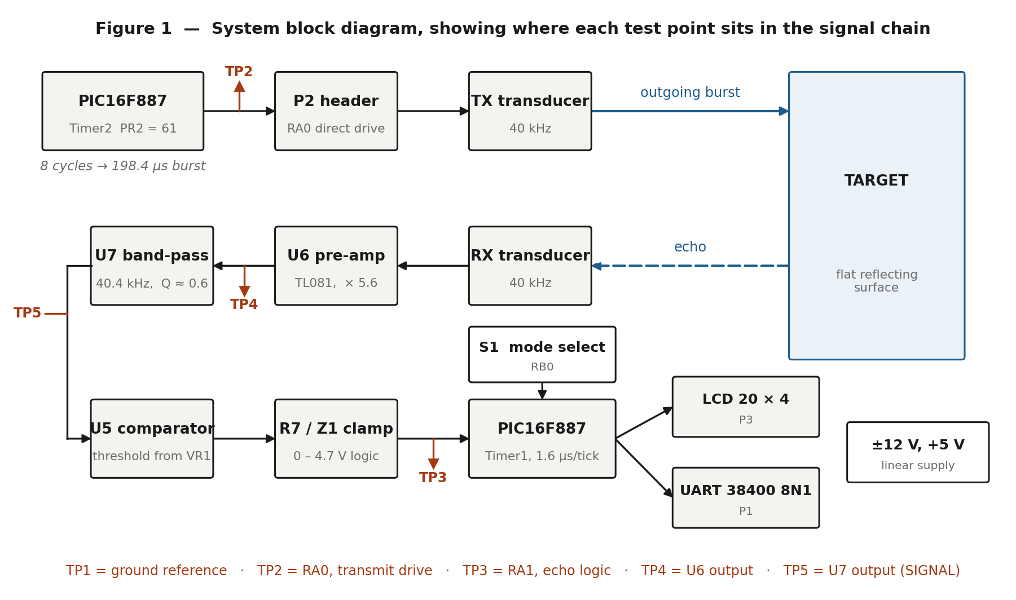
Figure 1 - Signal flow around the board, with the five test points marked.

3.2 One measurement, step by step
- Timer2 in the PIC16F887 free-runs and sets its flag every 12.4 microseconds. The firmware toggles pin RA0 on every flag, which produces a 40.32 kHz square wave.
- Sixteen toggles - eight complete cycles, 198.4 microseconds - are emitted and RA0 is then parked low. Header P2 connects RA0 directly to the transmitting transducer, so the transducer sees a 5 V peak-to-peak square wave. TP2 is on this net.
- The firmware waits out a blanking interval, then zeroes Timer1 and starts watching pin RA1.
- The burst travels to the target, reflects, and returns. The receiving transducer on P5 converts it back into a few millivolts of 40 kHz electrical signal.
- U6 amplifies that signal by 5.6 and presents it at TP4.
- U7 is a band-pass filter centred on 40.4 kHz. It rejects low-frequency room noise and anything well above the transducer band. Its output, the net named SIGNAL, is at TP5.
- U5 compares SIGNAL against the threshold voltage set by VR1. When the echo exceeds the threshold, U5 swings positive; R7 and Z1 clip that swing into a 0 to 4.7 V logic level for the microcontroller. TP3 is on this net, which is pin RA1.
- The firmware captures Timer1 on the first rising edge at RA1, converts ticks to centimetres, writes the LCD and sends the same number out of the serial port, then waits 500 ms and pings again.

3.3 Connectors, controls and test points

Connectors
Ref | Type | Function | Pin assignment
P4 | 3-pin header | Transformer secondary input | 1 = 12 V a.c., 2 = centre tap (0 V), 3 = 12 V a.c.
P2 | 2-pin header | Transmitting transducer | 1 = GND, 2 = RA0 drive
P5 | 2-way screw terminal | Receiving transducer | 1 = signal to R11, 2 = GND
P1 | 4-pin header | TTL serial, 38400 8N1 | 1 = +5 V, 2 = RXD (RC7), 3 = TXD (RC6), 4 = GND
P3 | 16-pin header | 20 x 4 character LCD | See Appendix A

Controls
Ref | Type | Function
S1 | SPDT slide switch | Mode select on RB0. One position gives 0 V at RB0 and selects distance ranging; the other gives +5 V and selects the continuous 40 kHz carrier.
S2 | Push button | Reset. Pulls MCLR (U1 pin 1) to ground.
VR1 | 1 k preset | Comparator threshold. Adjustable from 0 V to about 0.88 V because R6 (4.7 k) sits above it.
Check this before you rely on the panel marking
The firmware treats RB0 = 0 as ranging and RB0 = 1 as the continuous carrier, but the wording placed beside S1 on the schematic reads the other way round. Put a meter on RB0 (U1 pin 33) and record which physical position gives 0 V. Section 6, Test 3 does exactly this.

Test points
Test point | Net / device pin | What it is | Instrument
TP1 | GND | Ground reference. The oscilloscope ground clip belongs here. | -
TP2 | RA0, U1 pin 2 | 40 kHz transmit drive, before the transducer | Scope, 2 V/div
TP3 | RA1, U1 pin 3 | Echo, after the comparator and the clamp - a logic signal | Scope, 2 V/div
TP4 | U6 pin 6 | Output of the receive pre-amplifier | Scope, 5 V/div, a.c. coupled
TP5 | U7 pin 6, net SIGNAL | Output of the band-pass filter, and the comparator input | Scope, 5 V/div, a.c. coupled

4. Circuit description, stage by stage
Reference designators follow the schematic in main.pdf. Sheet PIC16F887.SchDoc carries the microcontroller, the LCD, the transmit header and the mode switch; sheet VI.SchDoc carries the power supply and the whole receive chain. Both sheets are reproduced at full size in Appendix F.

4.1 Stage 0 - Power supply
A 12-0-12 V, 500 mA transformer secondary arrives on P4. Because the winding has a centre tap that is grounded, the four 1N4007 diodes form two full-wave rectifiers rather than one bridge: D2 and D3 conduct on the positive half-cycles and charge C12, while D1 and D4 conduct on the negative half-cycles and charge C11. The result is a symmetrical raw supply of roughly +17 V and -17 V with respect to ground.
Regulator | Input | Output | Feeds
U4 LM7812 | raw + rail on C12 (1000 uF) | +12 V | Op-amp positive rail, and the input of U3
U2 LM7912 | raw - rail on C11 (1000 uF) | -12 V | Op-amp negative rail
U3 LM7805 | +12 V | +5 V | PIC16F887, LCD, LCD backlight, VR1 divider
C13, C14, C6, C7, C8, C9 and C10 are the input and output capacitors the regulators need for stability; C17 to C25 are 0.1 uF decoupling capacitors placed at each op-amp's supply pins. Note that U3 drops the full 7 V from +12 V to +5 V, so with the LCD backlight drawing 30 to 40 mA through R4 it dissipates around 0.4 W and will run warm. A small clip-on heatsink is worthwhile.
Why plus and minus 12 V for a 5 V board?
The three TL081 stages are d.c.-coupled with their non-inverting inputs at ground, so their outputs have to be able to swing symmetrically about 0 V. A single supply would need a mid-rail reference and a.c. coupling everywhere. Split rails keep the analogue design simple and let the comparator idle at its negative rail, which is exactly the behaviour the clamp in Section 4.6 relies on.

4.2 Stage 1 - Microcontroller core, clock and reset
U1 is a PIC16F887 in a 40-pin DIP package, running from a 20 MHz crystal X1 with 22 pF loading capacitors C3 and C5, in HS oscillator mode. The instruction cycle is therefore Fosc/4 = 5 MHz, or 200 ns, and this is the timebase for both timers.
Signal | Device pin | Direction | Connected to
MCLR | 1 | in | R5 10 k pull-up to +5 V, C2 0.1 uF to ground, reset button S2
RA0 | 2 | out | TP2 and P2 pin 2 - transmit drive
RA1 | 3 | in | TP3 - echo logic from the comparator clamp
VDD | 11, 32 | - | +5 V, decoupled by C1 and C4
VSS | 12, 31 | - | Ground
OSC1 / OSC2 | 13, 14 | - | X1 20 MHz with C3, C5
RC0 | 15 | out | LCD E (P3 pin 6), with R2 8.2 k pull-down
RC6 / TX | 25 | out | P1 pin 3, TXD
RC7 / RX | 26 | in | P1 pin 2, RXD
RB0 | 33 | in | S1 through R3 4.7 k - mode select
RB1, RB2 | 34, 35 | out | LCD RS and RW
RB4 to RB7 | 37 to 40 | out | LCD D4 to D7
A classic first-time trap
On the PIC16F887 the ANSEL and ANSELH registers power up with the pins configured as analogue inputs. A digital read of RA1 would return zero for ever. The first two statements in main() are setup_adc_ports(NO_ANALOGS) and setup_adc(ADC_OFF), which is what makes RA0, RA1 and RB0 behave as ordinary digital I/O.

4.3 Stage 2 - The 40 kHz transmitter
This is the simplest stage on the board and the one with the biggest engineering consequence. Timer2 is loaded with PR2 = 61 and runs with no prescaler, so its flag sets every 62 instruction cycles:
Timer2 period = (PR2 + 1) x Tcy = 62 x 200 ns = 12.4 us
RA0 is toggled on each flag, so a full square-wave cycle is 24.8 us
f = 1 / 24.8 us = 40 322 Hz = 40.32 kHz
40.32 kHz is the closest a 20 MHz clock can come to 40 kHz with an integer divider, and it is comfortably inside the bandwidth of a 40 kHz transducer. Loading PR2 with 62 instead would give 39.68 kHz, which is useful if a particular transducer pair happens to peak below 40 kHz.
Header P2 takes RA0 straight to the transducer, with the other terminal grounded. There is no MOSFET, no driver and no step-up transformer, so the transducer sees a 0 to 5 V square wave. A 40 kHz open-type transducer looks like roughly 2 nF at these frequencies, which at 40 kHz draws under a milliampere on average - well inside the 25 mA a PIC port pin can supply.
Why the acoustic output is modest
An HC-SR04 drives its transducer differentially through a step-up transformer at something like 20 V peak-to-peak. This board drives it single-ended at 5 V - about a quarter of the drive voltage, and since acoustic power goes as the square of the drive, more than an order of magnitude less sound. Expect useful readings out to one or two metres against a good flat target rather than the four metres a commercial module claims. If more range is needed, increase BURST_CYCLES from 8 to 12 or 16 - and raise BLANK_TIME_US to match, because a longer burst rings down for longer.
Note also that RA0 idles low. If the pin were parked high, the full 5 V would sit across the transducer between pings, and the falling edge at the start of each burst would be an extra impulse for the receiver to recover from. The routine tx_half_cycles() emits an even number of half-cycles precisely so that the pin lands back on the idle level of its own accord.

4.4 Stage 3 - Receiving transducer and pre-amplifier (U6)
The receiving transducer connects to the screw terminal P5, with pin 2 grounded. From there:
- R11, 10 k in series with C21, 0.1 uF forms the input path to the summing node of U6. The capacitor blocks any d.c. offset from the transducer and, with R11, puts a high-pass corner at about 159 Hz - far below the signal of interest and far above nothing that matters.
- U6 (TL081) is wired as an inverting amplifier with its non-inverting input at ground and R9, 56 k as the feedback resistor.
Gain = - R9 / R11 = - 56 k / 10 k = - 5.6 (15.0 dB)
The output, U6 pin 6, is brought out at TP4. With no acoustic input this node should sit within about 100 mV of ground: the TL081's input offset voltage multiplied by 5.6 is only a few tens of millivolts. Anything near +11 V or -11 V means the stage is saturated or one of the supply rails is missing.
A TL081 is used rather than the LM741 shown in older revisions of this project because a 741's 0.5 V/us slew rate cannot reproduce a 40 kHz signal of any useful amplitude, whereas the TL081 manages 13 V/us. If you are working from an older board or an older netlist, check which part is actually fitted - it changes the results dramatically.

4.5 Stage 4 - The 40 kHz band-pass filter (U7)
U7 and its four passive components form a multiple-feedback band-pass filter, one of the standard single-op-amp active filter topologies. It is worth recognising, because it appears constantly in sensor front ends.
Component | Value | Role in the topology
R12 | 330 ohm | Input resistor from the previous stage into node A
C22 | 0.01 uF | From node A to the inverting input (the virtual earth)
C16 | 0.01 uF | From node A back to the output - the second feedback path
R10 | 470 ohm | From the output to the inverting input
- | - | The optional resistor from node A to ground is omitted on this board
With both capacitors equal to C, the standard results are:
f0 = 1 / ( 2 pi C sqrt(R12 x R10) )
= 1 / ( 2 pi x 0.01 uF x sqrt(330 x 470) ) = 40.4 kHz

Q = 0.5 x sqrt(R10 / R12) = 0.5 x sqrt(470/330) = 0.60

midband gain = - R10 / (2 x R12) = - 470 / 660 = - 0.71 (-3.0 dB)
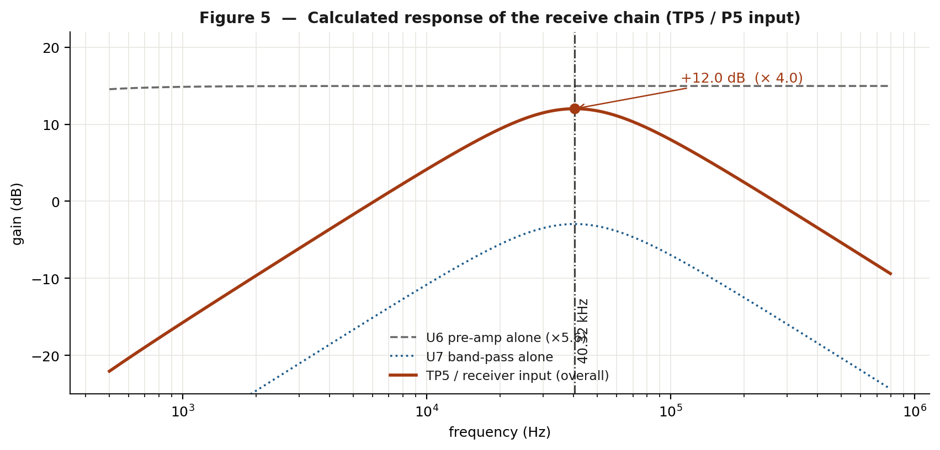
Figure 5 - Calculated response of the two receive stages, individually and combined.
Two things follow, and both surprise students the first time:
- The filter has a loss, not a gain. A signal at TP5 is about 30 % smaller than the same signal at TP4. The stage is there to shape the spectrum, not to make the signal bigger.
- The Q is low - about 0.6 - so the skirts are gentle. The -3 dB bandwidth is around 68 kHz. It removes mains hum, footsteps and general low-frequency air movement, and it rolls off well above the transducer band, but it is nothing like a narrow 40 kHz filter.
The overall receive-chain gain at 40 kHz is therefore 5.6 x 0.71 = about 4.0, or 12 dB. That is modest, and it is why VR1 usually has to be set near the low end of its range.
A design exercise for the student
If you wanted 40 dB of gain at 40 kHz with the same topology, what would you change, and what would happen to f0 and to Q? Note that in this topology the midband gain, the centre frequency and the Q are all set by the same two resistors, so they cannot be chosen independently - which is exactly why the omitted third resistor exists in the textbook version of the circuit.

4.6 Stage 5 - Threshold comparator (U5) and logic-level clamp
U5 is a third TL081, used here as a comparator (open loop, no feedback). Its inputs are:
- Pin 3, non-inverting: the net SIGNAL, straight from the filter output at TP5.
- Pin 2, inverting: the threshold. R6 (4.7 k) from +5 V sits above VR1 (1 k) whose lower end is grounded, so the voltage across VR1 is 5 x 1 / 5.7 = 0.877 V, and the wiper can be set anywhere from 0 V to about 0.88 V. C15 (0.1 uF) keeps that node quiet.
Because the threshold is positive and SIGNAL rests at 0 V, U5 idles at its negative rail. Its output then passes through R7 (1 k) to the clamp network at RA1:
- Z1, a 4.7 V zener with its cathode on the RA1 net, limits positive excursions to 4.7 V - a safe logic high for a 5 V part.
- On negative excursions Z1 conducts in the forward direction, so RA1 rests at roughly -0.7 V, which the PIC reads as a solid logic low. R7 limits the current in that state to about 10 mA.
- R8, 33 k to ground, is a weak pull-down that defines the node if U5 is not fitted.
Expect a negative reading at TP3
A voltmeter on TP3 with the board idle will read about -0.6 to -0.7 V, not 0 V. That is normal and is caused by Z1 conducting forwards. If TP3 sits at 0 V instead, U5 is probably not powered.
There is no envelope detector anywhere in this chain. During an echo the comparator therefore chatters at 40 kHz, and TP3 shows a burst of narrow pulses rather than one long pulse. That is perfectly adequate, because ranging only ever needs the first rising edge - and the firmware only ever times the first one. Figure 2 in Section 5 shows exactly this.

4.7 Stage 6 - Mode switch S1
S1 is a single-pole double-throw switch with one throw on +5 V and the other on ground; the common terminal reaches RB0 through R3 (4.7 k). Because both ends are driven, RB0 is never floating and no pull-up or pull-down resistor is needed. R3 simply limits the current if RB0 were ever accidentally configured as an output.
RB0 level | Mode | What the board does
0 V (low) | Distance ranging | Pings every 500 ms, displays the distance, sends it on the serial port
+5 V (high) | Continuous carrier | RA0 runs continuously at 40.32 kHz; the LCD shows '40KHz TX ON' and 'No Measurement'; no ranging is done
Continuous-carrier mode is not decoration - it is a test aid. With the transmitter running all the time the receive chain sees a steady 40 kHz tone, which makes it far easier to measure stage gains and to check the filter than a 200 microsecond burst that arrives every half second. Experiment 2 depends on it.

4.8 Stage 7 - Display and serial output

LCD
A standard HD44780-compatible 20 x 4 character module connects to P3 and is driven in 4-bit mode.
P3 pin | LCD function | Connected to
1 | GND | Ground
2 | VCC | +5 V
3 | ADJ (contrast) | R1, 2.2 k, to ground - a fixed contrast setting
4 | RS | RB1
5 | RW | RB2 (the driver polls the busy flag, so R/W is genuinely used)
6 | EN | RC0, with R2 8.2 k pull-down to ground
7 to 10 | D0 to D3 | Not connected - 4-bit mode
11 to 14 | D4 to D7 | RB4 to RB7
15 | BK+ (backlight anode) | R4, 47 ohm, to +5 V
16 | BK- (backlight cathode) | Ground
Two details are worth pointing out. First, R2 holds the LCD enable line low while RC0 is high-impedance during reset, so the display cannot see a spurious enable pulse before the firmware has initialised it. Second, R/W is wired to a port pin rather than tied to ground, so flex_lcd.c reads the busy flag instead of relying on fixed delays - a more robust arrangement, at the cost of one pin.

Serial
RC6 and RC7 come out on P1 at TTL levels, 38400 baud, 8 data bits, no parity, one stop bit. There is no MAX232, so a USB-to-TTL adapter connects directly: adapter RX to P1 pin 3 (TXD), adapter TX to P1 pin 2 (RXD), and grounds together on pin 4.
Do not back-feed the board
P1 pin 1 carries +5 V. If the board already has its own supply, leave that pin unconnected on the adapter, otherwise two 5 V sources are being tied together.

5. How the firmware works

5.1 Files and building
File | Contents
Ultrasound.c | The application: carrier generation, ranging, display and serial output
flex_lcd.c | 4-bit HD44780 driver. The LCD pin assignment is at the top of this file and must match the schematic
Ultrasound.ccspjt | CCS IDE project file
Ultrasound.hex | Build output, programmed into the PIC16F887
The compiler is CCS PICC 5.019 or later. From a command line:
ccsc +FM Ultrasound.c
or open the project in the CCS IDE and build. The configuration line in the source is:
#use delay(clock=20000000)
#fuses NOWDT, HS, PUT, MCLR, PROTECT, NODEBUG, NOBROWNOUT, NOLVP,
CPD, NOWRT, NOFCMEN, NOIESO
#use rs232(baud=38400, xmit=PIN_C6, rcv=PIN_C7)
HS selects the high-speed crystal oscillator for the 20 MHz crystal, PUT enables the power-up timer, NOWDT disables the watchdog, and NOLVP frees RB3 from low-voltage programming duty. PROTECT and CPD read-protect the program and data memory - remember to clear those if you want to read the part back.

5.2 Generating the carrier, and why it is polled
Timer2 provides the 40 kHz timebase, but its interrupt is never enabled. The firmware polls the flag instead:
void tx_half_cycles(int16 n)
{
TX_OFF();
clear_interrupt(INT_TIMER2);

while(n--)
{
while(!interrupt_active(INT_TIMER2)) ;
clear_interrupt(INT_TIMER2);
output_toggle(TX_PIN);
}
TX_OFF();
}
The reason is a timing budget. At 80 000 toggles per second there are only 62 instruction cycles between events, and the context save and restore that the CCS compiler generates around an interrupt service routine costs more than that on its own. Polling keeps the loop body to a few instructions and the edge placement exact. This is a genuinely useful lesson: interrupts are not automatically the right answer - above a few tens of kilohertz on an 8-bit part they stop being affordable.
The parameter n counts half cycles, and it is always even, so the pin lands back on its idle low level by itself and the closing TX_OFF() adds no extra edge for the receiver to ring on.

5.3 One ranging cycle
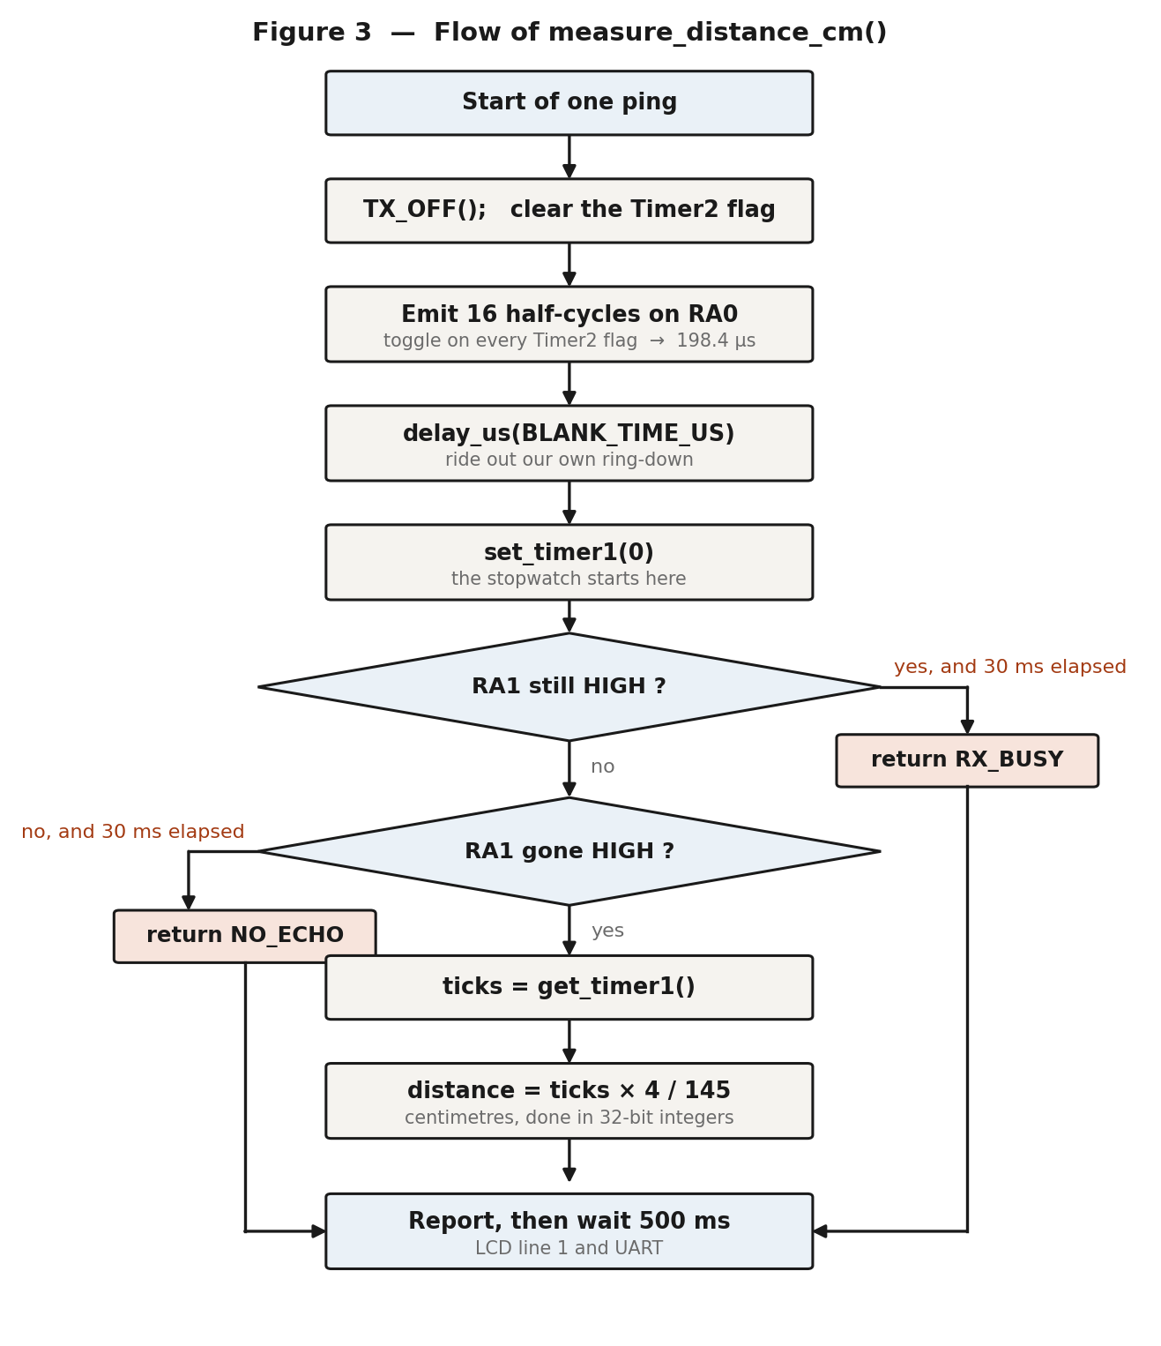
Figure 3 - The measurement function, measure_distance_cm().
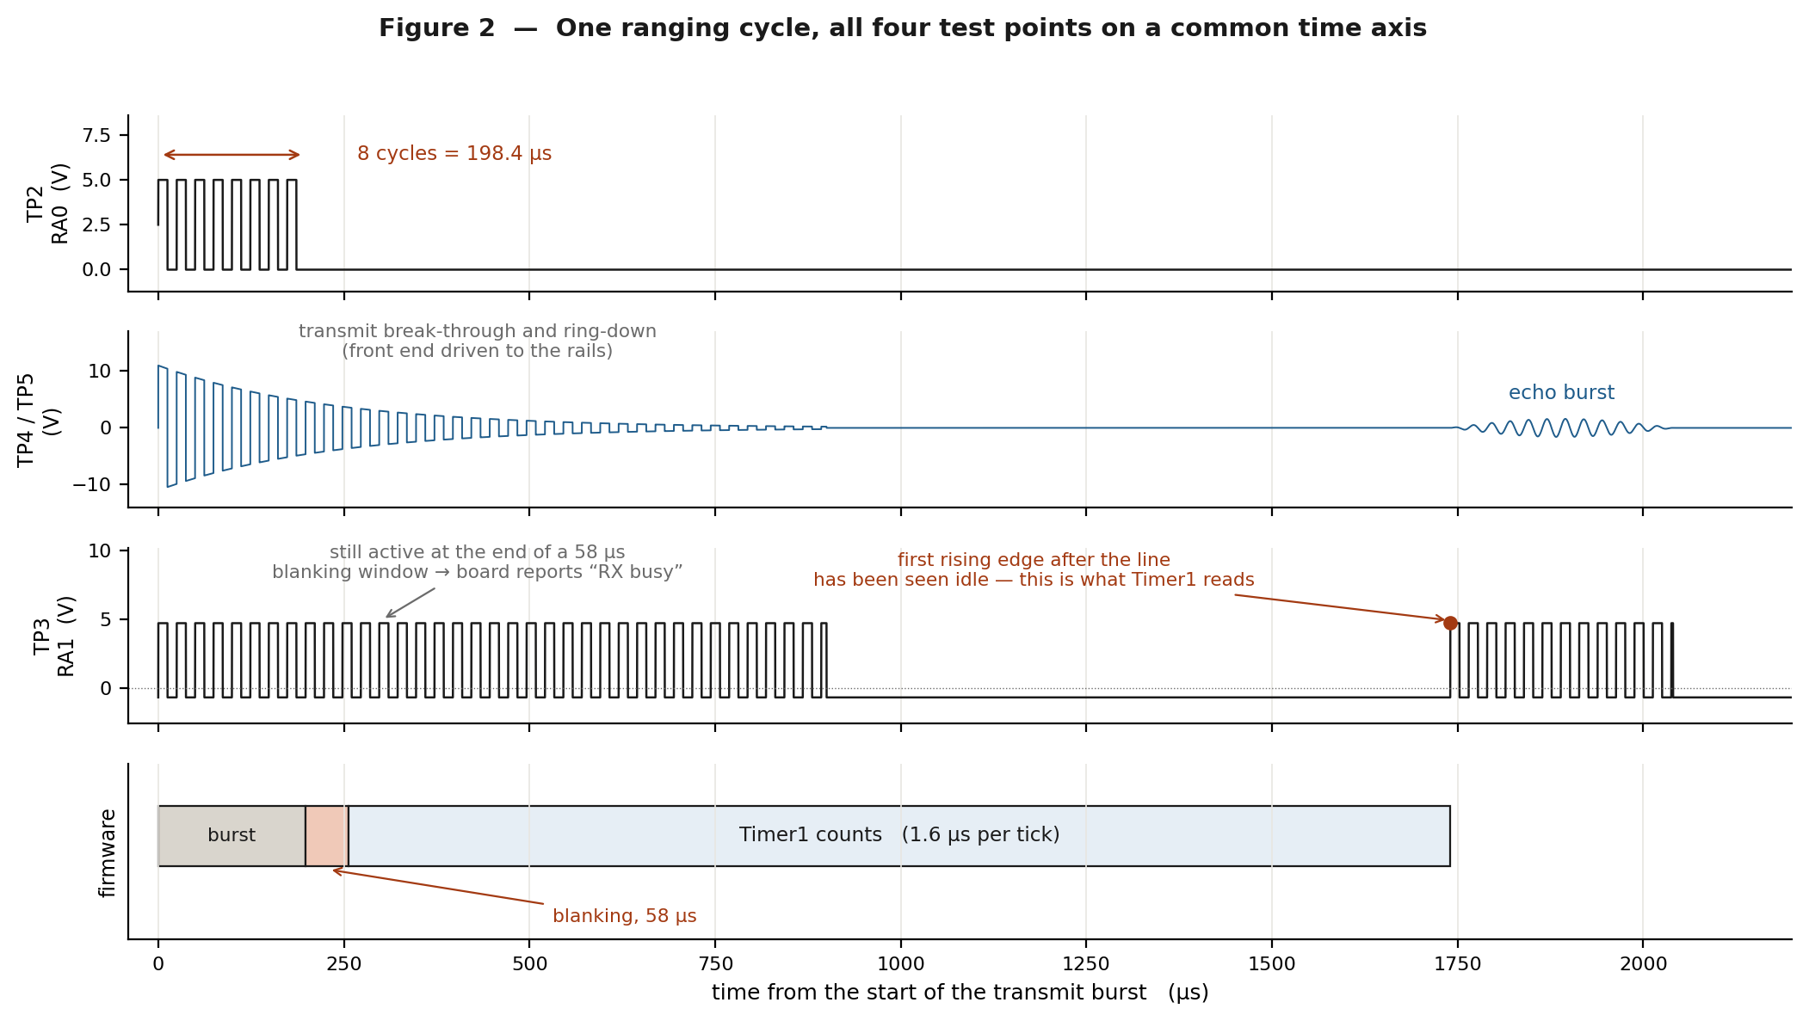
Figure 2 - The same cycle in time. Note that TP3 is a burst of pulses, not a single long pulse, because there is no envelope detector in the receive chain.
Reading Figure 2 from the top:
- TP2 carries eight cycles of 40.32 kHz, 198.4 microseconds in total, and then goes quiet until the next ping 500 ms later.
- TP4 and TP5 are slammed to the supply rails during the burst. This is not a fault - it is transmit break-through plus the transducer's own ring-down, and a TL081 driven to its rails takes a finite time to come back. The echo, when it arrives, is a much smaller packet.
- TP3 is high wherever SIGNAL exceeds the threshold. During the ring-down that is most of the time, which is why the blanking window exists.
- The firmware bar shows the burst, the blanking window, and the interval that Timer1 actually counts.
A subtle point worth marking in your report
Timer1 is zeroed after the blanking delay, not at the end of the burst. Every reading is therefore short by exactly the blanking time - that is, by BLANK_TIME_US / 58 centimetres. With the shipped value of 58 microseconds that is 1 cm; if you raise the blanking to 600 microseconds it becomes 10 cm and must be compensated in ECHO_OFFSET_TICKS.

5.4 Turning ticks into centimetres
Timer1 runs from the instruction clock with a divide-by-8 prescaler:
tick = 8 / (Fosc/4) = 8 / 5 MHz = 1.6 us

distance_cm = time_us / 58 = (ticks x 1.6) / 58 = ticks x 4 / 145
The multiply-then-divide is done in a 32-bit intermediate because ticks can reach 18 750 and 18 750 x 4 = 75 000, which overflows 16 bits. Doing it this way keeps the floating-point library out of an 8 K part entirely - a technique worth having in your toolbox.
Quantity | Value | Comes from
Timer1 resolution | 1.6 us = 0.0276 cm | One tick
Timeout | 18 750 ticks = 30.0 ms = 517 cm | ECHO_TIMEOUT_TICKS
Timer1 rollover | 65 536 ticks = 104.9 ms | 16-bit counter - comfortably beyond the timeout
Measurement rate | 2 per second | delay_ms(500) at the end of the loop
Note that the resolution of the timer (0.028 cm) is far finer than the resolution of the measurement. The display shows whole centimetres, and the real uncertainty comes from the comparator threshold, the transducer ring-up and the temperature of the air - not from the timer.

5.5 The two failure reports
The firmware never invents a number. There are exactly two ways for a ping to fail, and each has its own message:
LCD shows | Serial sends | Meaning
--- | Out of range | Nothing crossed the threshold within 30 ms. The target is too far, too small, too soft or too oblique - or VR1 is set too high.
RX busy | Echo line still active after blanking - check RA1 | RA1 was still asserted when the blanking window closed. The receive chain has not recovered, or VR1 is wound so far down that U5 is triggering on its own noise. The next edge would be our own ping, so the reading is refused rather than reported.
Why this matters
A cheaper design would simply have returned the blanking floor - a plausible-looking small number - and the student would have believed it. Refusing to report a measurement that is known to be meaningless is good instrument design, and it is worth saying so in your report.

5.6 The display and the serial stream
In ranging mode the LCD shows the distance on line 1 from column 8, in a field padded to eight characters so that a shorter reading cannot leave the tail of a longer one behind:
Line 1: Dist = 123 cm
Line 2: SASTHA'S

and in continuous-carrier mode:

Line 1: 40KHz TX ON
Line 2: No Measurement
The serial port carries the same information, one line per ping at 38400 baud, 8N1:
Distance = 123 cm
Distance = 124 cm
Out of range
Echo line still active after blanking - check RA1
40KHz continuous TX mode

5.7 The three constants you may need to change
Constant | Shipped value | What it does | How to choose it
BURST_CYCLES | 8 | Number of 40 kHz cycles per ping | Raise to 12 or 16 for more range on this low-drive board. Raise BLANK_TIME_US to match.
BLANK_TIME_US | 58 | How long the firmware ignores its own ring-down | Minimum range in cm is this value divided by 58. See Section 7.2 - 58 us is almost certainly too short in practice.
ECHO_OFFSET_TICKS | 0 | Fixed lag through the receive chain, in 1.6 us ticks, subtracted from every reading | Measure a known distance D, read what the display says R, set this to (R - D) x 36. See Section 7.3.

6. Stage-by-stage testing
Work through these tests in order. Each one assumes the one before it passed. If a test fails, stop and fix it there - carrying on past a failed stage is how an afternoon disappears.

6.0 Before power is applied
- Inspect the board for solder bridges, especially around the 40-pin socket and the regulator pins.
- Confirm the three regulators are the right way round and that U2 is an LM7912 (negative) and U4 an LM7812 (positive). Swapping them destroys both.
- Check the polarity of C11 and C12. C12's positive terminal goes to the raw positive rail; C11's positive terminal goes to ground, because it sits on the negative rail. This catches out almost everyone.
- With a meter on continuity, verify that there is no short between +5 V and ground, between +12 V and ground, or between -12 V and ground.
- Confirm the ICs are in their correct sockets and that pin 1 of each faces the notch. TL081s in place of the LM741s shown on older drawings are correct for this revision.
- Confirm the transmitter is on P2 and the receiver on P5. They look identical; if they are swapped the board will transmit into the receiver's terminal and nothing will work.

6.1 Summary of what you should see
Point | Instrument | Idle (no echo) | During a ping
Raw + rail (C12 +) | DMM d.c. | +15 to +19 V | -
Raw - rail (C11 -) | DMM d.c. | -15 to -19 V | -
+12 V (U4 pin 3) | DMM d.c. | +11.6 to +12.4 V | -
-12 V (U2 pin 3) | DMM d.c. | -11.6 to -12.4 V | -
+5 V (U3 pin 3) | DMM d.c. | +4.8 to +5.2 V | -
TP2 (RA0) | Scope 2 V/div, 10 us/div | 0 V | 8 cycles, 0 to 5 V, 40.3 kHz, 198 us long, every 500 ms
TP4 (U6 pin 6) | Scope 5 V/div a.c., 200 us/div | within 0.1 V of 0 V | clipped at about +/-11 V during the burst, decaying; echo packet later
TP5 (U7 pin 6) | Scope 5 V/div a.c., 200 us/div | within 0.1 V of 0 V | same shape as TP4, about 30 % smaller
VR1 wiper (U5 pin 2) | DMM d.c. | 0 to 0.88 V, set by you | unchanged
TP3 (RA1) | Scope 2 V/div, 200 us/div | about -0.7 V | bursts of pulses between -0.7 V and +4.7 V

Test 1 - Supply rails
Set up | Board powered from the transformer secondary on P4. No probe on the analogue nodes yet. Black meter lead on TP1.
Do | Measure, in this order: the raw rails at C12 and C11, then +12 V at U4 pin 3, -12 V at U2 pin 3, and +5 V at U3 pin 3.
Expect | The values in the table above. All three regulated rails should be within 5 % and steady.
If it fails | No raw rails at all: check the transformer, P4 wiring and that the centre tap really is on P4 pin 2. Raw rail present but no regulated output: the regulator is faulty, fitted the wrong way round, or its output is shorted. Only one polarity missing: check the diode pair for that half - D2/D3 feed the positive rail, D1/D4 the negative.

Test 2 - The microcontroller is alive
Set up | Rails confirmed. LCD fitted to P3 the right way round.
Do | Apply power and watch the display for the first two seconds. Press S2 and watch it again.
Expect | The backlight lights, and after about half a second line 1 reads 'Dist =' and line 2 reads SASTHA'S. Pressing S2 restarts that sequence.
If it fails | Backlight on but no characters: check +5 V at P3 pin 2, and check R1 (contrast) is fitted. A row of solid blocks means the LCD is powered but never initialised - check RC0, RB1, RB2 and RB4 to RB7 continuity, and that R2 is pulling EN down. Nothing at all: check MCLR sits at +5 V (R5), and put a scope on OSC2 to confirm the 20 MHz crystal is running.

Test 3 - Mode switch and RB0
Set up | Meter between TP1 and U1 pin 33 (RB0).
Do | Move S1 to each position in turn and record the voltage. Write down which physical position gives 0 V - this is the ranging position, whatever the panel says.
Expect | One position gives 0 V, the other +5 V. Nothing in between, and no drift, because both throws are driven.
If it fails | A voltage around 2.5 V means the switch common is open - check S1 and R3 (4.7 k). Confirm at the same time that the LCD changes to '40KHz TX ON' in the +5 V position; if the display does not follow the switch, the firmware is not reading RB0, which usually means the ADC ports were not turned off.

Test 4 - The 40 kHz transmit drive at TP2
Set up | S1 in the ranging position. Scope on TP2, ground clip on TP1, 2 V/div, 10 us/div, trigger on the rising edge, normal (not auto) mode.
Do | Measure the period of one cycle, count the number of cycles in the packet, then switch to 100 us/div and measure the packet length. Finally go to 100 ms/div and measure the interval between packets.
Expect | Period 24.8 us (40.3 kHz), a clean 0 to 5 V square wave, 8 cycles, 198 us long, repeating every 500 ms.
If it fails | No output at all: RA0 is still configured as an analogue pin, or the part is not programmed. Wrong frequency: check the crystal is 20 MHz and that the HS fuse is set - a part running on its internal oscillator gives roughly a sixth of the frequency. Rounded edges and reduced amplitude: normal if the transducer is connected, since it is a capacitive load; disconnect P2 to see the unloaded waveform.

Test 5 - The transmitter is actually making sound
Set up | S1 in the continuous carrier position. LCD should read '40KHz TX ON'.
Do | Hold the receiving transducer (still on P5) facing the transmitter about 50 mm away and look at TP4 on the scope, a.c. coupled, 5 V/div, 20 us/div.
Expect | A steady 40 kHz waveform at TP4, large or even clipped at that spacing. Move the receiver away and the amplitude falls smoothly.
If it fails | TP2 correct but nothing at TP4: the transmitting transducer is open, the wrong device is on P2 (a receiver rather than a transmitter), or the receive chain is dead - continue with Test 6 to find out which. Nothing at either point: go back to Test 4.

Test 6 - The pre-amplifier, U6
Set up | Continuous carrier mode, receiver about 300 mm from the transmitter and facing it. Scope channel 1 on P5 pin 1, channel 2 on TP4, both a.c. coupled.
Do | First check the d.c. condition: with the transmitter switched back off, TP4 must sit within about 0.1 V of ground. Then switch the carrier on and measure the peak-to-peak amplitude at both points.
Expect | The ratio TP4 / P5 should be 5.6, set by R9 / R11. The waveform at TP4 is inverted relative to the input.
If it fails | TP4 stuck near +11 V or -11 V: the stage is saturated. Check that both +12 V and -12 V reach U6 pins 7 and 4, and that C21 is not short-circuited. A gain well below 5.6: check R9 (56 k) and R11 (10 k) values and solder joints. No signal at P5 either: the receiving transducer or its wiring is open.

Test 7 - The band-pass filter, U7
Set up | As Test 6, but with channel 1 on TP4 and channel 2 on TP5.
Do | Measure the peak-to-peak amplitude at both points and take the ratio.
Expect | About 0.71 - the filter attenuates slightly at its own centre frequency. TP5 is inverted with respect to TP4. Both should be centred on 0 V.
If it fails | A ratio far from 0.71 points at R10 (470 R), R12 (330 R), C16 or C22. If the output is a d.c. level with no signal, check the supplies on U7 pins 7 and 4. Remember that this stage should lose about 3 dB - a student who expects gain here will report a fault that does not exist.

Test 8 - Setting the threshold on VR1
Set up | Meter on U5 pin 2 (the wiper node), black lead on TP1.
Do | Turn VR1 from end to end and record the range of the voltage.
Expect | Adjustable from about 0 V up to 0.88 V. That ceiling is set by R6 (4.7 k) above VR1 (1 k) from the 5 V rail: 5 x 1 / 5.7 = 0.877 V.
If it fails | A range of 0 to 5 V means R6 is missing or shorted. No adjustment at all means the wiper is open - a very common failure in cheap presets. Set VR1 to about 0.15 V for now; Section 7.1 tunes it properly.

Test 9 - The echo logic at TP3
Set up | Back to ranging mode. Scope channel 1 on TP2 (trigger source), channel 2 on TP3, 2 V/div, 200 us/div, trigger on the rising edge of channel 1. A flat target about 300 mm in front of the transducers.
Do | Observe TP3 across the whole sweep. Identify the ring-down region immediately after the burst, the quiet interval, and the returning echo.
Expect | TP3 idles at about -0.7 V. Immediately after the burst it is a solid run of pulses (the ring-down). It then goes quiet, and a distinct burst of pulses appears at the echo time - about 1.74 ms for a 300 mm target.
If it fails | TP3 permanently high: VR1 is too low and U5 is triggering on noise, or SIGNAL has a d.c. offset. TP3 permanently at -0.7 V with a good signal at TP5: VR1 is set higher than the echo amplitude - wind it down. TP3 sitting at 0 V: U5 has no supplies.

Test 10 - End to end
Set up | Ranging mode, flat target on a metre scale, USB-to-TTL adapter on P1 (pin 3 to the adapter's RX, pin 4 to ground) with a terminal at 38400 8N1.
Do | Place the target at 30, 50 and 100 cm and compare the display, the serial line and the tape measure.
Expect | All three agree to within a few centimetres. Readings update twice a second.
If it fails | '---' at every distance: see Section 9. 'RX busy' at every distance: see Section 7.2 - this is the expected symptom of too short a blanking time. Serial garbage: the baud rate is wrong, or the adapter's ground is not connected.

7. Calibration
Three adjustments turn a working board into an accurate one. Do them in this order, because each one depends on the previous.

7.1 The threshold, VR1
VR1 trades sensitivity against noise immunity, and there is no single correct setting - it depends on the transducers, the target and the room.
- Put a flat target at the longest distance you want the board to work at, square-on.
- Starting from the top of VR1's range, wind the threshold down slowly until the display first shows a stable reading instead of '---'.
- Wind it down a little further - perhaps another 10 % of the range - so that there is some margin.
- Now remove the target entirely and point the board at open space. The display should return to '---' and stay there. If it starts showing random numbers or 'RX busy', the threshold is too low; wind it back up.
- Record the wiper voltage. On a typical board it will be somewhere between 50 mV and 300 mV.
What you are really seeing
The overall gain of this receive chain at 40 kHz is only about 4, so the echo at TP5 is small and the useful threshold sits near the bottom of VR1's travel. Increasing BURST_CYCLES, or driving the transmitter harder, would let you use a higher and therefore more noise-immune threshold. That trade-off is the substance of Experiment 6, Part D.

7.2 The blanking time, BLANK_TIME_US
This constant sets how long the firmware ignores its own transmission. The shipped value is 58 microseconds, which corresponds to a 1 cm blanking floor - shorter than a 40 kHz transducer takes to stop ringing. The comment beside it in the source is written for a value of 600.
Symptom of too short a blanking time: the display reads 'RX busy' on most or all pings, because RA1 is still asserted by the ring-down when the window closes.
- Put the scope on TP3, triggered from TP2, and measure how long the ring-down pulses actually last on your board. Call that value Tr.
- Set BLANK_TIME_US to about 1.2 x Tr, rebuild and reprogram.
- Confirm that 'RX busy' has gone and that real readings appear.
- Now walk the value back down until 'RX busy' returns, then go back up one step. This gives the shortest blanking - and therefore the smallest minimum range - that your board can support.
BLANK_TIME_US | Minimum measurable range | Comment
58 (as shipped) | 1 cm | Shorter than the ring-down. Expect 'RX busy'.
600 | 10 cm | The HC-SR04 figure. A sensible first try.
1500 | 26 cm | Usually enough on a board with TL081s.
3000 | 52 cm | Safe but wasteful - only if the front end recovers very slowly.

7.3 The fixed offset, ECHO_OFFSET_TICKS
Every reading is late by a fixed amount - the propagation delay through the amplifier, the filter and the comparator, plus the time the transducer takes to ring up to the threshold - and early by the blanking time, which Timer1 does not count. The net error is constant with distance, so one measurement removes it.
- Place a flat target at a carefully measured distance, D centimetres. Use something in the middle of your working range, around 100 cm.
- Take ten readings and average them. Call the average R.
- Set the constant as follows, rebuild and reprogram:
ECHO_OFFSET_TICKS = (R - D) x 58 / 1.6 = (R - D) x 36

Example: D = 100 cm, R = 104 cm -> (104-100) x 36 = 144 ticks
- Re-check at two other distances. Because the error is a constant offset, correcting it at one distance should correct it everywhere. If the error instead grows with distance, the problem is the scale factor - that is a speed-of-sound or temperature issue, not an offset (see Section 2.3).
If the reading is short rather than long
R - D can be negative, for example if the blanking time is large and the receive chain is fast. The firmware only subtracts a positive offset, so a negative result means you should reduce BLANK_TIME_US instead, or add the correction in the display routine. Note in your report which way your board errs and why.

7.4 Calibration record
Item | Value | Date | By
VR1 wiper voltage
BLANK_TIME_US
ECHO_OFFSET_TICKS
BURST_CYCLES
Ambient temperature
Minimum range achieved
Maximum range achieved

8. Experiments
Experiments 1 to 4 are the core set and need only the board, an oscilloscope and a metre scale. Experiment 5 requires the CCS compiler and a programmer because firmware constants are changed. Experiments 6 to 8 are extensions.
For every experiment, record the ambient temperature at the start. Section 2.3 explains why.

Experiment 1 - The 40 kHz carrier and the transmit burst

Aim
To observe the transmitted burst at TP2, to verify that its frequency, length and repetition rate agree with the values calculated from the firmware constants, and to relate each of them to a line of source code.

Apparatus
Trainer board, dual-channel oscilloscope with x10 probes, multimeter.

Theory
Timer2 counts instruction cycles. With Fosc = 20 MHz the instruction cycle is 200 ns. With PR2 = 61 and no prescaler the timer flag sets every 62 cycles, and RA0 is toggled on every flag, so one complete square-wave cycle takes two flag periods:
T = 2 x (PR2 + 1) x 4 / Fosc = 2 x 62 x 4 / 20 MHz = 24.8 us
f = 1 / T = 40.32 kHz

burst length = BURST_CYCLES x T = 8 x 24.8 us = 198.4 us
repetition period = delay_ms(500) = 500 ms

Procedure
- Set S1 to the ranging position (the one you identified in Test 3 as giving 0 V at RB0).
- Clip the probe ground to TP1 and the tip to TP2. Set 2 V/div and 10 us/div. Trigger on the rising edge, normal mode - auto-trigger will not hold a picture of a burst that arrives twice a second.
- Measure the period of one cycle and calculate the frequency. Measure the high time and the low time to check the duty cycle.
- Change the timebase to 50 us/div and count the number of complete cycles in the packet. Measure the total packet length.
- Change to 100 ms/div and measure the interval between packets.
- Disconnect the transducer at P2 and repeat step 3. Note any change in the shape of the edges.

Observations
Quantity | Calculated | Measured | Difference
Cycle period T (us) | 24.8
Frequency f (kHz) | 40.32
Duty cycle (%) | 50
Cycles per burst | 8
Burst length (us) | 198.4
Repetition interval (ms) | 500
Amplitude, loaded (V p-p) | -
Amplitude, unloaded (V p-p) | 5.0

Result and discussion
- State the measured carrier frequency and the percentage difference from 40.32 kHz.
- Explain why loading the pin with the transducer rounds the edges. What kind of load is a piezo transducer at 40 kHz?
- What frequency would PR2 = 62 give? Which of the two would you choose for a transducer whose measured resonance is 39.5 kHz?
- The firmware polls the Timer2 flag instead of using an interrupt. Calculate how many instruction cycles are available between toggles and explain why this makes an interrupt impractical.

Experiment 2 - Gain of the receive chain

Aim
To measure the voltage gain of the pre-amplifier and of the band-pass filter at 40 kHz and compare each with the value calculated from the component values.

Theory
U6 inverting amplifier: A1 = - R9 / R11 = - 56k / 10k = - 5.6

U7 multiple-feedback band-pass filter:
f0 = 1 / (2 pi C sqrt(R12 R10)) = 40.4 kHz
Q = 0.5 sqrt(R10 / R12) = 0.60
A2 = - R10 / (2 R12) = - 0.71

Overall at 40 kHz: A1 x A2 = 5.6 x 0.71 = 4.0 (12 dB)

Procedure
- Put S1 in the continuous carrier position. The LCD should read '40KHz TX ON'. The receiver now sees a steady tone, which is far easier to measure than a 200 us burst.
- Arrange the transmitting and receiving transducers facing a flat target about 300 mm away, or simply face them at each other across the bench at a spacing that gives a comfortable, unclipped signal at TP4. If TP4 is clipping at the rails, increase the spacing.
- Measure the peak-to-peak voltage at P5 pin 1 (the receiver terminal), at TP4 and at TP5. Use a.c. coupling on all three.
- Repeat at two further spacings so that you have three sets of readings.
- With channel 1 on TP4 and channel 2 on TP5, note the phase relationship between the two.

Observations
Spacing (mm) | V at P5 (mV p-p) | V at TP4 (V p-p) | V at TP5 (V p-p) | A1 = TP4/P5 | A2 = TP5/TP4

Result and discussion
- Compare the mean measured A1 with 5.6 and the mean measured A2 with 0.71. Account for any difference.
- A x10 scope probe presents about 10 megohm and 12 pF. Does connecting it to P5 change the reading? Estimate the loading effect at 40 kHz.
- Why does the filter stage have a loss rather than a gain? What is it there for, if not to amplify?
- Both stages are inverting. What is the total phase shift from P5 to TP5 at 40 kHz, and does it matter for this application?
- If you needed 40 dB of gain in the receive chain, where would you add it, and what would you have to watch out for?

Experiment 3 - Verifying the time-of-flight relationship

Aim
To show experimentally that the round-trip time is directly proportional to the distance to the target, to determine the constant of proportionality, and from it to calculate the speed of sound in the laboratory.

Theory
From Section 2.1, t = 2d / c. A plot of t against d is therefore a straight line through the origin with slope 2/c. Measuring the slope gives the speed of sound directly.

Procedure
- Ranging mode. Fix a flat target, at least 300 x 300 mm, so that it can slide along a metre scale and stay square-on to the transducers.
- Measure from the front face of the transducers to the target face. Be consistent - a systematic error here appears as an offset in the results.
- Set the oscilloscope with channel 1 on TP2 as the trigger source and channel 2 on TP3. Trigger on the rising edge of channel 1, normal mode, 500 us/div.
- At each distance, measure the interval from the start of the burst on TP2 to the first rising edge of the echo group on TP3. Record it as t.
- At the same time, record what the LCD displays.
- Repeat for distances from 20 cm to 150 cm in 10 cm steps.

Observations
True distance d (cm) | Measured time t (us) | t / d (us per cm) | LCD reading (cm)
20
30
40
50
60
70
80
90
100
120
150

Calculations
- Plot t (vertical) against d (horizontal). Draw the best straight line through the points.
- Find the slope, in microseconds per centimetre. It should be close to 58.
- Calculate the speed of sound from c = 2 / slope. Convert to metres per second.
slope = 2 / c (us per cm, with c in cm per us)

example: slope = 58.4 us/cm
c = 2 / 58.4 = 0.03425 cm/us = 342.5 m/s
- Compare with the theoretical value c = 331.3 + 0.606 T for the temperature you recorded.
- Note the intercept of your best-fit line. A non-zero intercept is the fixed delay of the receive chain, and is exactly what ECHO_OFFSET_TICKS is meant to remove (Section 7.3).
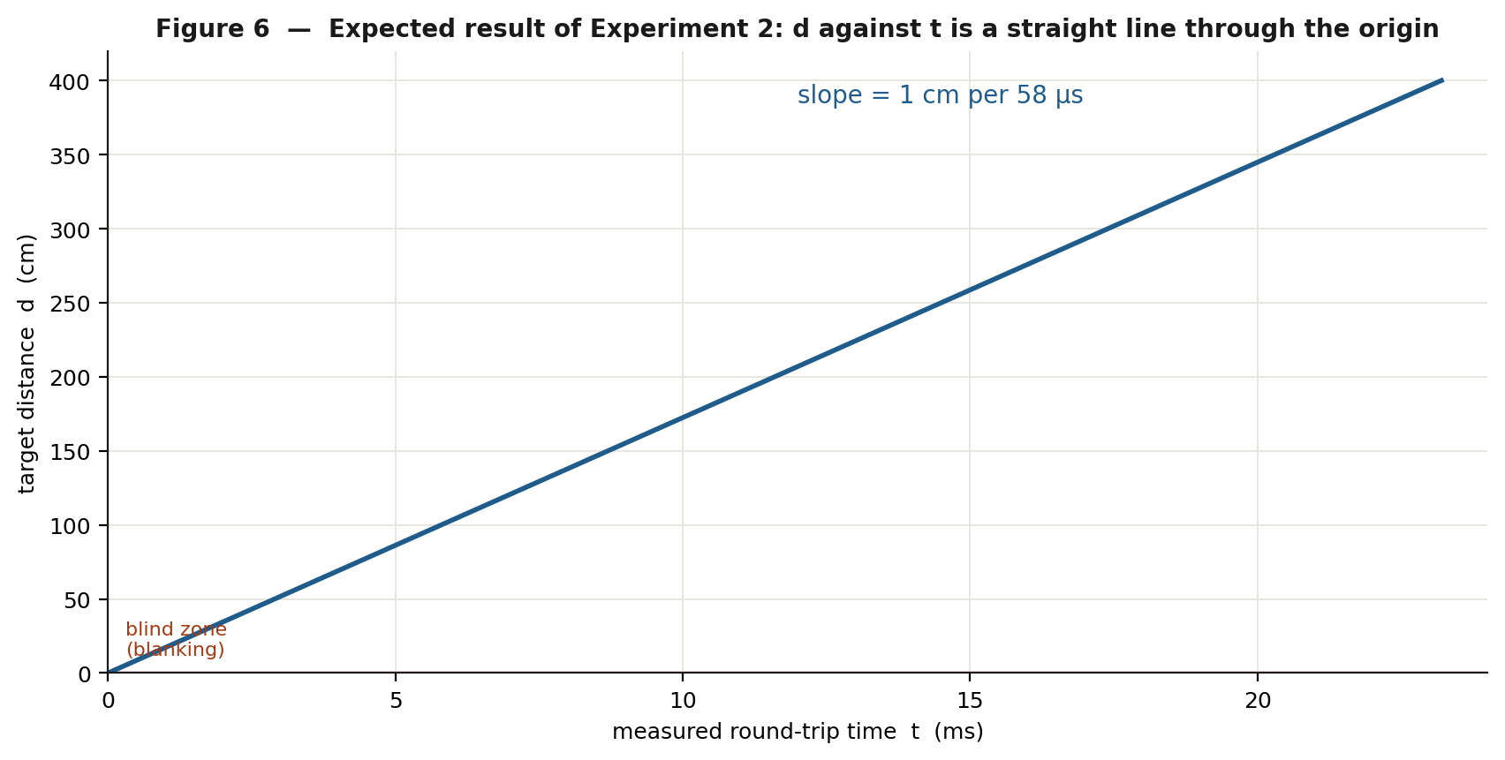
Figure 6 - The expected shape of the Experiment 3 result.

Result and discussion
- State the measured speed of sound and the percentage difference from the theoretical value at the measured temperature.
- Why is the plot of t against d not expected to pass exactly through the origin?
- The firmware assumes 58 us/cm. If your measured value is 59.3 us/cm, by what percentage will the display read high or low, and in which direction?

Experiment 4 - Accuracy, linearity and repeatability of the display

Aim
To characterise the instrument: how close each reading is to the truth, how the error varies with distance, and how much the reading scatters when nothing is changed.

Procedure
- Ranging mode, same target and scale as Experiment 3.
- At each distance take five consecutive readings from the display without touching anything.
- Work from 20 cm out to the largest distance at which readings remain stable, in 20 cm steps.
- Record any distance at which the display shows '---' or 'RX busy' instead of a number - those are results too.

Observations
True d (cm) | R1 | R2 | R3 | R4 | R5 | Mean (cm) | Error (cm) | Error (%)
20
40
60
80
100
120
140
160
180
200

Calculations
- For each distance: mean, error = mean - true, percentage error = 100 x error / true.
- Plot displayed reading (vertical) against true distance (horizontal), and draw the ideal y = x line on the same axes.
- Fit a straight line to your points. The intercept is the fixed offset; the slope tells you whether the 58 us/cm constant matches the air in your laboratory.
- Calculate the spread (maximum minus minimum of the five readings) at each distance. This is the repeatability.
- From the mean error at your reference distance, calculate the value of ECHO_OFFSET_TICKS that would remove it: (R - D) x 36.

Result and discussion
- Quote the accuracy of the instrument as '+/- x cm, or +/- y % of reading, whichever is greater' over the range you tested.
- Is the error mainly an offset, a scale error, or random scatter? Each has a different cause and a different cure - say which applies to your board.
- The timer resolution is 0.028 cm. Your repeatability is almost certainly far worse than that. List the sources of uncertainty that dominate.

Experiment 5 - The blind zone and the blanking time
This experiment changes firmware constants
The board must be rebuilt with the CCS compiler and reprogrammed between runs. Keep a copy of the original Ultrasound.c before you start, and record every value you try.

Aim
To measure the minimum distance the board can report, and to show that it is set by BLANK_TIME_US and not by anything acoustic or electrical.

Theory
The firmware waits BLANK_TIME_US after the burst before it starts listening, so any echo returning sooner than that is discarded. Since 58 microseconds corresponds to 1 cm:
minimum range (cm) = BLANK_TIME_US / 58

Procedure
- With the board as shipped (BLANK_TIME_US = 58), start with the target at 60 cm and move it in towards the transducers in 2 cm steps.
- Record the distance at which the display stops giving sensible numbers, and record exactly what it shows instead - a stuck value, '---' or 'RX busy'.
- Rebuild with BLANK_TIME_US = 600, reprogram and repeat.
- Repeat again for 1500 and for 3000.
- For one of these settings, put the scope on TP3 triggered from TP2 and measure how long the ring-down pulses actually last. Compare that duration with the blanking value that first gave clean readings.

Observations
BLANK_TIME_US | Predicted minimum (cm) | Observed minimum (cm) | What the display shows below it | Ring-down duration at TP3 (us)
58 (as shipped)
600
1500
3000

Result and discussion
- Does the observed minimum follow BLANK_TIME_US / 58? Where it does not, explain why - what physical effect takes over?
- Explain in your own words why 58 microseconds is too short for a real transducer, and what the 'RX busy' message is telling you.
- Timer1 is started after the blanking delay. By how much does that make every reading under-read at each of the four settings, and how would you compensate?
- What is the trade-off in choosing the blanking time? What do you lose by making it generously long?

Experiment 6 - Maximum range: target size, material and angle

Aim
To show that the maximum range of an ultrasonic ranger is set by the strength of the returning echo, not by the timing electronics, and to quantify how target properties affect it.

Procedure

Part A - a good target
- Ranging mode, VR1 at the setting recorded in Section 7.1. Use a rigid flat board about 300 x 300 mm, square-on.
- Move it away from the board until the display shows '---' consistently. Record the last distance at which readings were stable.

Part B - other targets
- Repeat Part A with: a 100 x 100 mm flat board; a cylindrical object such as a 75 mm pipe; the same flat board covered with a thick cloth; and a sheet of foam.

Part C - angle
- Put the 300 x 300 mm board at a fixed 100 cm and rotate it about a vertical axis in 10 degree steps. Record the reading, and the angle at which it fails.

Part D - threshold
- Return to Part A's setup. Lower VR1 in small steps and repeat the maximum-range measurement at each setting, noting also whether the board starts producing false readings when the target is removed.

Observations
Target | Maximum range (cm) | Remarks
300 x 300 mm flat board
100 x 100 mm flat board
75 mm cylinder
Cloth-covered board
Foam sheet
Angle (degrees) | 0 | 10 | 20 | 30 | 40 | 50
Reading at 100 cm
VR1 wiper (mV) | Maximum range (cm) | False readings with no target?

Result and discussion
- Rank the targets by maximum range and explain the ordering in terms of reflected acoustic energy.
- A flat target tilted by 30 degrees reflects the sound away from the receiver, like a mirror. Explain why a cylinder is often detected at angles where a flat plate is not.
- Describe the trade-off you found in Part D. Is there a threshold setting that gives both maximum range and zero false readings?
- The firmware times out at 30 ms, equivalent to 517 cm. Did you ever reach that limit? What actually limited your range?

Experiment 7 (extension) - Beam width
Aim: to measure the effective beam angle of the transducer pair.
- Place the flat target at a fixed 100 cm and mark the centre line of the transducers on the bench.
- Move the target sideways in 5 cm steps, keeping it at the same 100 cm perpendicular distance and still facing the board, and record whether a reading is obtained and what it says.
- Find the lateral offset x at which readings just stop on each side.
- The half-angle is arctan(x / 100). Double it for the full beam angle.
Lateral offset x (cm) | -25 | -20 | -15 | -10 | -5 | 0 | 5 | 10 | 15 | 20 | 25
Reading (cm) or '---'
- Compare your measured beam angle with the 30 degrees typical of a 16 mm open-type transducer.
- Note that the reading at a large offset is longer than 100 cm. Why? What does that tell you about what an ultrasonic ranger actually measures?

Experiment 8 (extension) - Serial logging and the temperature correction
Aim: to capture the measurement stream over the serial port and to quantify the temperature-dependent scale error.
- Connect a USB-to-TTL adapter: adapter RX to P1 pin 3 (TXD), ground to P1 pin 4. Leave P1 pin 1 unconnected if the board has its own supply.
- Open a terminal at 38400 baud, 8 data bits, no parity, one stop bit, and log to a file.
- Record 100 consecutive readings with the target fixed at 100 cm. Import the log into a spreadsheet.
- Calculate the mean and the standard deviation. This is a far better estimate of repeatability than reading the LCD by eye.
- Measure the air temperature T. Calculate c = 331.3 + 0.606 T, then the true microseconds per centimetre, 2 x 10000 / c (with c in m/s).
- Calculate the percentage scale error that the fixed 58 us/cm introduces, and check it against the slope you found in Experiment 4.
T = 30 degC -> c = 331.3 + 0.606 x 30 = 349.5 m/s
true us per cm = 20000 / 349.5 = 57.2
error of using 58 = (57.2 - 58) / 58 = -1.4 %
a 100 cm target would read about 98.6 cm
- If you were to add a temperature sensor to this board, where in the firmware would the correction go, and what would it change?
- Over what temperature range would this board hold 1 % accuracy without correction?

9. Troubleshooting
Symptom | Most likely causes | What to check
Nothing on the LCD, backlight off too | No +5 V | Test 1. Check U3 output, R4 (47 R) and the P3 connector orientation
Backlight on, screen blank | Contrast or initialisation | R1 (2.2 k) fitted? +5 V on P3 pin 2? Check RB1, RB2, RC0 and RB4-RB7 for continuity
A row of solid blocks | LCD powered but never initialised | The enable line is not toggling. Check RC0 and R2 (8.2 k). Confirm the PIC is running by scoping OSC2
LCD correct but the reading never changes | Firmware not reaching the ranging branch | Check RB0 with a meter (Test 3). If RB0 is high the board is in carrier mode by design
'---' at every distance | No echo is crossing the threshold | In order: TP2 (Test 4), TP4 (Test 6), TP5 (Test 7), then wind VR1 down. Check the transducers are not swapped between P2 and P5
'RX busy' at every distance | The echo line is still active when blanking ends | Raise BLANK_TIME_US (Section 7.2). Also check that VR1 is not at the ground end, and that TP5 has no d.c. offset
Reading stuck at a small value | Same cause as 'RX busy' | The board is timing its own ring-down. Raise BLANK_TIME_US
Readings jump about wildly | Threshold too low, or a poor target | Raise VR1 slightly. Use a larger, harder, square-on target. Check for another ultrasonic source in the room
Readings consistently a few cm high | Fixed delay through the receive chain | Normal. Calibrate ECHO_OFFSET_TICKS (Section 7.3)
Error grows in proportion to distance | Scale error, not offset | The air is not at 22 degC, or the crystal is not 20 MHz. See Section 2.3
TP4 or TP5 stuck at +11 V or -11 V | Op-amp saturated or a supply missing | Check +12 V on pin 7 and -12 V on pin 4 of that device. Check the feedback resistor is not open
TP3 sits at 0 V instead of -0.7 V | U5 unpowered, or Z1 missing | Check U5 supplies and that Z1 is fitted the right way round, cathode to the RA1 net
Nothing on the serial port | Baud rate, wiring or a level clash | 38400 8N1. Adapter RX goes to P1 pin 3, grounds must be common. Do not connect the adapter's 5 V if the board is separately powered
U3 (7805) very hot | Normal, but check the load | It drops 7 V. Measure the +5 V current; the backlight through R4 is most of it. Fit a heatsink
One supply rail missing | One rectifier pair or one regulator | D2 and D3 feed the positive rail, D1 and D4 the negative. Check the raw rail first, then the regulator

10. Review and viva questions
Answers are in Appendix E.
- Why is the measured time divided by two before it is converted into a distance?
- Derive the constant 58 microseconds per centimetre from first principles, stating the speed of sound you assume.
- Why is a burst of eight cycles transmitted rather than a single pulse?
- What sets the minimum measurable distance of this board, and what sets the maximum?
- The carrier is 40.32 kHz rather than exactly 40 kHz. Why, and does it matter?
- Calculate the gain of the U6 stage and explain why an inverting configuration was chosen.
- Name the filter topology used around U7 and write down expressions for its centre frequency, its Q and its midband gain.
- The band-pass stage attenuates rather than amplifies. Justify its presence in the circuit.
- What is the purpose of Z1, and why does TP3 sit at about -0.7 V when the board is idle?
- Why does the echo appear at TP3 as a series of pulses rather than as one long pulse, and why does that not matter?
- What is the resolution of the Timer1 measurement in centimetres, and why is the real uncertainty of the instrument much larger?
- Explain the difference between the '---' message and the 'RX busy' message.
- Why is the 40 kHz carrier generated by polling a timer flag rather than by a timer interrupt?
- Why must setup_adc_ports(NO_ANALOGS) be called before RA1 is read?
- The distance calculation is written as ticks x 4 / 145 in 32-bit arithmetic. Explain both the 4/145 and the choice of 32 bits.
- The board uses +12 V, -12 V and +5 V. Why does a 5 V microcontroller board need split supplies at all?
- How would the readings change if the laboratory were at 5 degC instead of 25 degC? Quantify your answer.
- This board drives the transducer directly from a port pin at 5 V, while a commercial module uses a step-up transformer. What are the consequences, and what firmware change partly compensates?

11. Notes for the instructor and the board maintainer
These are points where the documents in the project folder disagree with each other or with the built hardware. None of them stops the board working, but each one will cost a student an afternoon if it is not known about.

11.1 Source comments describe an earlier revision
The header comment in Ultrasound.c describes the receive chain in terms of LM741 op-amps and refers to R14, R15, C19, C23 and 'R9 1K to RA1'. The current schematic uses TL081 devices throughout and the designators are R11, R12, R9, R10, C21, C22, C16 and R7. The functional description in the comment is still correct; only the part numbers and the reference designators are stale. The TL081 change matters: a 741 cannot slew fast enough to reproduce 40 kHz usefully, so the comment's remark about a large fixed delay caused by 741 slew rate no longer applies, and ECHO_OFFSET_TICKS should come out much smaller than it once did.

11.2 BLANK_TIME_US is set to 58, but its comment is written for 600
The constant as shipped gives a 1 cm blanking floor, which is shorter than the ring-down of any real 40 kHz transducer. The expected symptom is 'RX busy' on most pings. Section 7.2 explains how to choose a working value. Consider changing the shipped default to 600 and letting students discover the effect by lowering it, rather than the other way round.

11.3 The mode-switch annotation may be reversed
On sheet PIC16F887.SchDoc the word 'Distance' is placed beside the S1 throw that connects to +5 V and 'Oscillator' beside the throw that connects to ground, while the firmware treats RB0 = 0 as ranging and RB0 = 1 as the continuous carrier. Verify on the built board and correct either the drawing or the panel legend. Test 3 in Section 6 has students confirm this with a meter before they rely on it.

11.4 The netlist and the bill of material in the project folder are out of date
main.NET and BOM.csv still list Q1 (IRF9540), its gate pull-up, D5 (FR107) and three LM741s - all of which have been removed or replaced on the current sheets. Regenerate both from the current schematic before any board is manufactured or any parts are ordered from them.

11.5 The RA1 clamp pulls the pin below ground
Because Z1's cathode is on the RA1 net, negative excursions of U5's output are clamped by Z1 conducting forwards, leaving RA1 at about -0.7 V. R7 limits the current to roughly 10 mA, which the PIC's input protection tolerates, but the pin is being held slightly outside its absolute-maximum input range. If the board is revised, a Schottky to ground plus a series resistor, or a comparator with a single-supply output stage, would be cleaner. It is worth pointing out to students as a real design compromise rather than hiding it.

11.6 Suggested spare parts for a laboratory set
TL081 (the most likely casualty of a probe slip), 1N4007, 40 kHz transducer pairs, 1 k presets, and a spare programmed PIC16F887.

Appendix A - Pin-out and connector reference

A.1 PIC16F887 (U1) - pins that are used
Pin | Name | Function on this board
1 | MCLR / VPP | Reset. R5 10 k to +5 V, C2 0.1 uF to ground, push button S2 to ground
2 | RA0 / AN0 | 40 kHz transmit drive. TP2, and P2 pin 2
3 | RA1 / AN1 | Echo input from the comparator clamp. TP3
11 | VDD_1 | +5 V
12 | VSS_1 | Ground
13 | OSC1 / CLKI | X1 20 MHz crystal, C3 22 pF to ground
14 | OSC2 / CLKO | X1 20 MHz crystal, C5 22 pF to ground
15 | RC0 / T1OSO | LCD enable (P3 pin 6). R2 8.2 k pull-down
25 | RC6 / TX | Serial transmit, P1 pin 3
26 | RC7 / RX | Serial receive, P1 pin 2
31 | VSS_2 | Ground
32 | VDD_2 | +5 V
33 | RB0 / INT | Mode select from S1 through R3 4.7 k
34 | RB1 | LCD RS (P3 pin 4)
35 | RB2 | LCD R/W (P3 pin 5)
37 | RB4 | LCD D4 (P3 pin 11)
38 | RB5 | LCD D5 (P3 pin 12)
39 | RB6 | LCD D6 (P3 pin 13)
40 | RB7 | LCD D7 (P3 pin 14)
All other pins are unconnected. C1 and C4, both 0.1 uF, decouple the two VDD pins.

A.2 Connectors
Connector | Pin | Signal | Notes
P4 (power in) | 1 | 12 V a.c. | Transformer secondary, 12-0-12, 500 mA
 | 2 | 0 V (centre tap) | Becomes the board ground
 | 3 | 12 V a.c.
P2 (transmitter) | 1 | GND
 | 2 | RA0 | Direct pin drive, 5 V peak-to-peak
P5 (receiver) | 1 | Signal | Into R11 10 k and C21
 | 2 | GND
P1 (serial) | 1 | +5 V | Leave unconnected if the board is separately powered
 | 2 | RXD (RC7) | Connect to the adapter's TX
 | 3 | TXD (RC6) | Connect to the adapter's RX
 | 4 | GND | Must be connected

A.3 LCD header P3
Pin | LCD signal | Board connection
1 | GND | Ground
2 | VCC | +5 V
3 | ADJ / V0 | R1 2.2 k to ground (fixed contrast)
4 | RS | RB1
5 | RW | RB2
6 | EN | RC0, with R2 8.2 k to ground
7 - 10 | D0 - D3 | Not connected (4-bit mode)
11 - 14 | D4 - D7 | RB4 - RB7
15 | BK+ | R4 47 R to +5 V
16 | BK- | Ground

Appendix B - Parts list, grouped by stage
Taken from the current schematic sheets. Note that main.NET and BOM.csv in the project folder pre-date this revision - see Section 11.4.

B.1 Power supply (sheet VI.SchDoc)
Reference | Value / device | Function
P4 | 3-pin header | Transformer secondary, 12-0-12 V, 500 mA
D1, D4 | 1N4007 | Negative half-wave rectifier pair
D2, D3 | 1N4007 | Positive half-wave rectifier pair
C11, C12 | 1000 uF, 25 V | Reservoir capacitors, negative and positive raw rails
U4 | LM7812 | +12 V regulator
U2 | LM7912 | -12 V regulator
U3 | LM7805 | +5 V regulator, fed from +12 V
C13, C6, C7, C9 | 10 uF | Regulator input and output capacitors
C8, C10, C14 | 0.1 uF | Regulator high-frequency bypass
C17, C19, C23 | 0.1 uF | +12 V decoupling at U6, U5 and U7
C18, C20, C24 | 0.1 uF | -12 V decoupling at U6, U5 and U7

B.2 Receive chain (sheet VI.SchDoc)
Reference | Value / device | Function
P5 | 2-way screw terminal | Receiving transducer
R11 | 10 k | Input resistor to the U6 summing node
C21 | 0.1 uF | Input coupling capacitor
U6 | TL081 | Inverting pre-amplifier, gain -5.6
R9 | 56 k | U6 feedback resistor
TP4 | Test point | U6 output
R12 | 330 R | Band-pass input resistor
C22 | 0.01 uF | Band-pass, node A to virtual earth
C16 | 0.01 uF | Band-pass, node A to output
R10 | 470 R | Band-pass feedback resistor
U7 | TL081 | Multiple-feedback band-pass, f0 = 40.4 kHz
TP5 | Test point | U7 output, net SIGNAL
R6 | 4.7 k | Top of the threshold divider, from +5 V
VR1 | 1 k preset | Threshold adjustment, 0 to 0.88 V
C15 | 0.1 uF | Threshold node decoupling
U5 | TL081 | Comparator, open loop
R7 | 1 k | Output series resistor into the clamp
Z1 | 4.7 V zener | Clamps RA1 to a safe logic level
R8 | 33 k | Weak pull-down on the RA1 net
TP3 | Test point | RA1

B.3 Microcontroller, display and transmitter (sheet PIC16F887.SchDoc)
Reference | Value / device | Function
U1 | PIC16F887, 40-pin DIP | Microcontroller
X1 | 20 MHz crystal | Clock, with C3 and C5 at 22 pF
C1, C4 | 0.1 uF | VDD decoupling
R5 | 10 k | MCLR pull-up
C2 | 0.1 uF | MCLR filter
S2 | Push button | Reset
S1 | SPDT slide switch | Mode select
R3 | 4.7 k | Series resistor from S1 to RB0
P2 | 2-pin header | Transmitting transducer
TP1, TP2 | Test points | Ground reference, and RA0
P1 | 4-pin header | TTL serial
P3 | 16-pin header | 20 x 4 LCD
R1 | 2.2 k | LCD contrast to ground
R2 | 8.2 k | LCD enable pull-down
R4 | 47 R | LCD backlight series resistor

Appendix C - Firmware and formula quick reference
Quantity | Expression | Value on this board
Instruction cycle | 4 / Fosc | 200 ns at 20 MHz
Carrier period | 2 x (PR2+1) x 4 / Fosc | 24.8 us
Carrier frequency | Fosc / (8 x (PR2+1)) | 40.32 kHz with PR2 = 61
Burst length | BURST_CYCLES x carrier period | 198.4 us with 8 cycles
Timer1 tick | 8 x 4 / Fosc | 1.6 us
Distance | ticks x 4 / 145 | cm, from 1.6 us ticks at 58 us/cm
Range resolution | 1.6 us / 58 | 0.028 cm per tick
Timeout | ECHO_TIMEOUT_TICKS x 1.6 us | 30.0 ms, about 517 cm
Minimum range | BLANK_TIME_US / 58 | 1 cm as shipped
Offset correction | (R - D) x 58 / 1.6 | (R - D) x 36 ticks
Speed of sound | 331.3 + 0.606 T | m/s, T in degrees Celsius
Microseconds per cm | 20000 / c | 58.0 at c = 344.8 m/s
Pre-amp gain | - R9 / R11 | -5.6
Filter centre frequency | 1 / (2 pi C sqrt(R12 R10)) | 40.4 kHz
Filter Q | 0.5 sqrt(R10 / R12) | 0.60
Filter midband gain | - R10 / (2 R12) | -0.71
Threshold range | 5 x VR1 / (VR1 + R6) | 0 to 0.877 V

C.1 Serial output strings
Distance = %3Lu cm normal reading
Out of range nothing came back in 30 ms
Echo line still active after blanking - check RA1 RX busy
40KHz continuous TX mode entering carrier mode

Appendix D - Bench card
A one-page summary to keep beside the board. Ground the probe at TP1 and nowhere else.
Point | Where | Idle | Active | Setting
+5 V | U3 pin 3 | 4.8 to 5.2 V | - | DMM
+12 V | U4 pin 3 | 11.6 to 12.4 V | - | DMM
-12 V | U2 pin 3 | -11.6 to -12.4 V | - | DMM
TP1 | Ground | 0 V | - | Probe ground clip
TP2 | RA0, U1 pin 2 | 0 V | 8 cycles, 0 to 5 V, 40.3 kHz, 198 us, every 500 ms | 2 V/div, 10 us/div
TP4 | U6 pin 6 | within 0.1 V of 0 V | rails during the burst, then the echo packet | 5 V/div a.c., 200 us/div
TP5 | U7 pin 6 | within 0.1 V of 0 V | as TP4, about 30 % smaller | 5 V/div a.c., 200 us/div
VR1 | U5 pin 2 | 0 to 0.88 V | unchanged | DMM
TP3 | RA1, U1 pin 3 | about -0.7 V | pulse bursts, -0.7 V to +4.7 V | 2 V/div, 200 us/div

If the display shows
Display | Meaning | First thing to try
--- | No echo within 30 ms | Wind VR1 down; check TP4 and TP5 have signal
RX busy | Echo line still active after blanking | Raise BLANK_TIME_US; check VR1 is not at the ground end
40KHz TX ON | S1 is in the continuous-carrier position | Move S1 to the ranging position
A number that never changes | Timing its own ring-down | Raise BLANK_TIME_US

Appendix E - Answers to the review questions
Q | Answer
1 | The sound travels from the transducer to the target and back again, so the measured time corresponds to twice the distance. Dividing by two converts the path length into the range.
2 | Take c = 344.8 m/s = 0.03448 cm/us. d = c t / 2 = 0.01724 t, so t = d / 0.01724 = 58.0 d. One centimetre of range therefore corresponds to 58 microseconds of round-trip time.
3 | A piezo transducer is a resonant device and needs several cycles to build up to full amplitude, so a single pulse would radiate very little energy. Eight cycles is a compromise: more cycles give more range but a longer packet and a longer ring-down, which raises the minimum measurable distance.
4 | The minimum is set by the blanking time in the firmware, during which the receiver is deliberately ignored while the transducer rings down: minimum range in cm equals BLANK_TIME_US divided by 58. The maximum is set by echo strength - beam spreading, absorption in air and the size, hardness and angle of the target - not by the 30 ms timeout, which corresponds to 5.17 m.
5 | 40.32 kHz is the closest a 20 MHz clock reaches with an integer timer reload (PR2 = 61 gives 12.4 us per half cycle). It does not matter, because the transducer's bandwidth is a few kilohertz wide; 0.8 % away from centre costs almost nothing in output.
6 | Gain = -R9 / R11 = -56 k / 10 k = -5.6. The inverting configuration puts the input at a virtual earth, which keeps the input impedance defined by R11 alone and makes the gain independent of the op-amp's common-mode behaviour. It also allows a simple d.c. path to ground on the non-inverting input.
7 | It is a multiple-feedback band-pass filter. With both capacitors equal to C: f0 = 1 / (2 pi C sqrt(R12 R10)), Q = 0.5 sqrt(R10 / R12), and the midband gain is -R10 / (2 R12). Here that gives 40.4 kHz, Q = 0.60 and a gain of -0.71.
8 | Its purpose is selectivity, not amplification. It removes low-frequency room noise, air movement and mains-related pickup, and rolls off well above the transducer band, so that the comparator sees mainly energy near 40 kHz. A gain of 0.71 costs 3 dB, which is a small price for the noise rejection.
9 | Z1 limits the comparator's output swing, which is roughly +/-11 V, to something the microcontroller can accept. Positive excursions are clamped at 4.7 V by zener action. Negative excursions make Z1 conduct in the forward direction, so the node rests one diode drop below ground, about -0.7 V, which the PIC reads as a logic low.
10 | There is no envelope detector in the chain, so the comparator follows the individual half-cycles of the 40 kHz echo and produces one pulse per cycle. It does not matter because ranging needs only the arrival time, and the firmware times the first rising edge after the line has been seen idle.
11 | One Timer1 tick is 1.6 us, which is 1.6/58 = 0.028 cm. The real uncertainty is far larger because the transducer takes several cycles to ring up to the threshold, the threshold itself depends on echo amplitude and therefore on distance, and the speed of sound varies with temperature.
12 | '---' means the timeout expired with no echo above the threshold: nothing came back. 'RX busy' means the echo line was still asserted when the blanking window closed, so the next edge would have been the board's own transmission; the reading is refused rather than reported as a false short distance.
13 | At 80 000 toggles per second there are only 62 instruction cycles between edges. The context save and restore that the compiler generates around an interrupt service routine costs more than that on its own, so an interrupt could not keep up. Polling the flag keeps the loop to a few instructions and the timing exact.
14 | On the PIC16F887 the ANSEL and ANSELH registers default to configuring the pins as analogue inputs after reset. A digital read of such a pin always returns zero, so RA1 would never appear to go high. setup_adc_ports(NO_ANALOGS) clears those registers and makes the pins digital.
15 | distance = time_us / 58 and time_us = ticks x 1.6, so distance = ticks x 1.6 / 58 = ticks x 4 / 145 after cancelling. Thirty-two-bit arithmetic is needed for the intermediate product, because ticks can reach 18 750 and 18 750 x 4 = 75 000, which will not fit in 16 bits. Doing it in integers avoids linking the floating-point library into an 8 K part.
16 | The three TL081 stages are d.c.-coupled with their non-inverting inputs at ground, so their outputs must swing symmetrically about 0 V. On a single supply each stage would need a mid-rail bias and a.c. coupling. Split rails also let the comparator idle at its negative rail, which is what makes the clamp arrangement at RA1 work.
17 | At 5 degC, c = 331.3 + 0.606 x 5 = 334.3 m/s, so the true figure is 20000 / 334.3 = 59.8 us per cm. The firmware assumes 58, so the display reads high by (59.8 - 58) / 58 = 3.1 %. A true 200 cm would read about 206 cm.
18 | A step-up transformer gives roughly four times the drive voltage and therefore much more acoustic power, so the commercial module reaches several metres where this board reaches one or two. Increasing BURST_CYCLES from 8 to 12 or 16 puts more energy into the air and recovers some of the range, at the cost of a longer ring-down - so BLANK_TIME_US must be raised to match, which increases the minimum measurable distance.

Appendix F - Schematic sheets
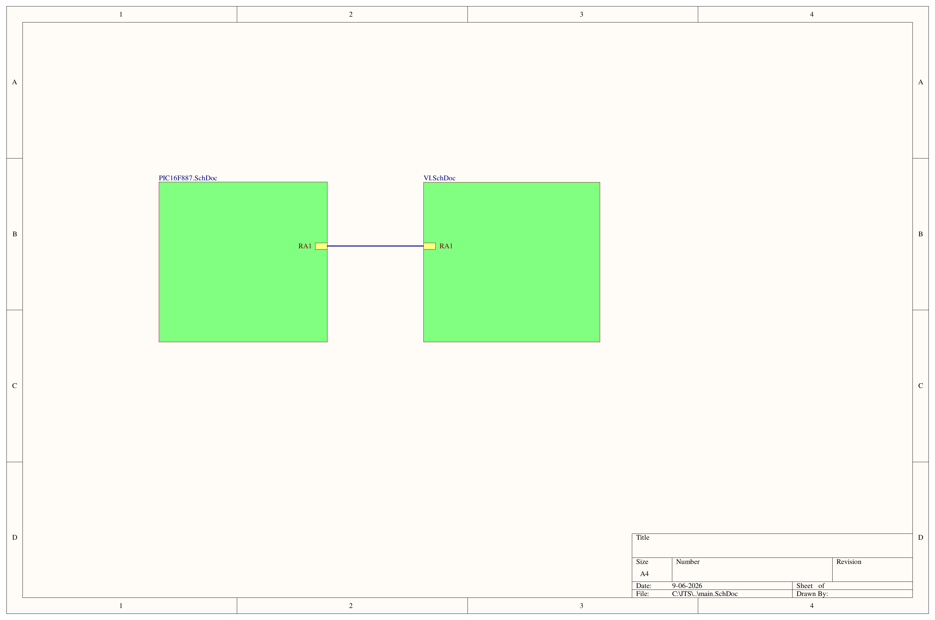
Figure F1 - main.SchDoc, the top-level sheet. It carries the two sub-sheets and the RA1 link between them.

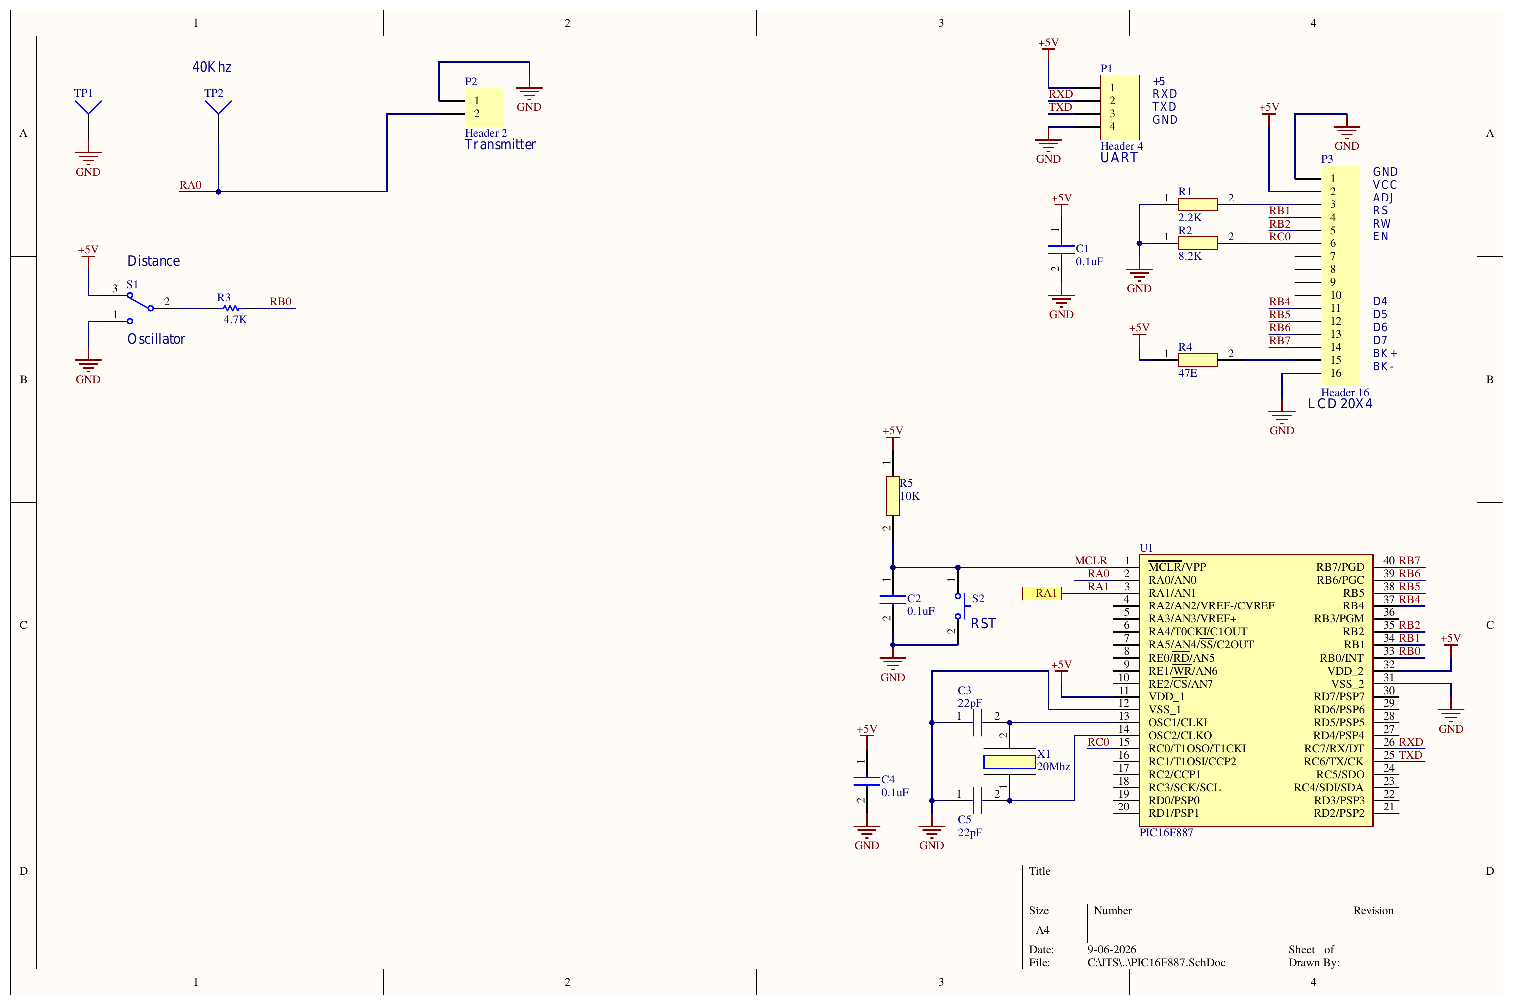
Figure F2 - PIC16F887.SchDoc: microcontroller, clock, reset, mode switch S1, transmit header P2, serial header P1 and the 20 x 4 LCD on P3. TP1 and TP2 are on this sheet.

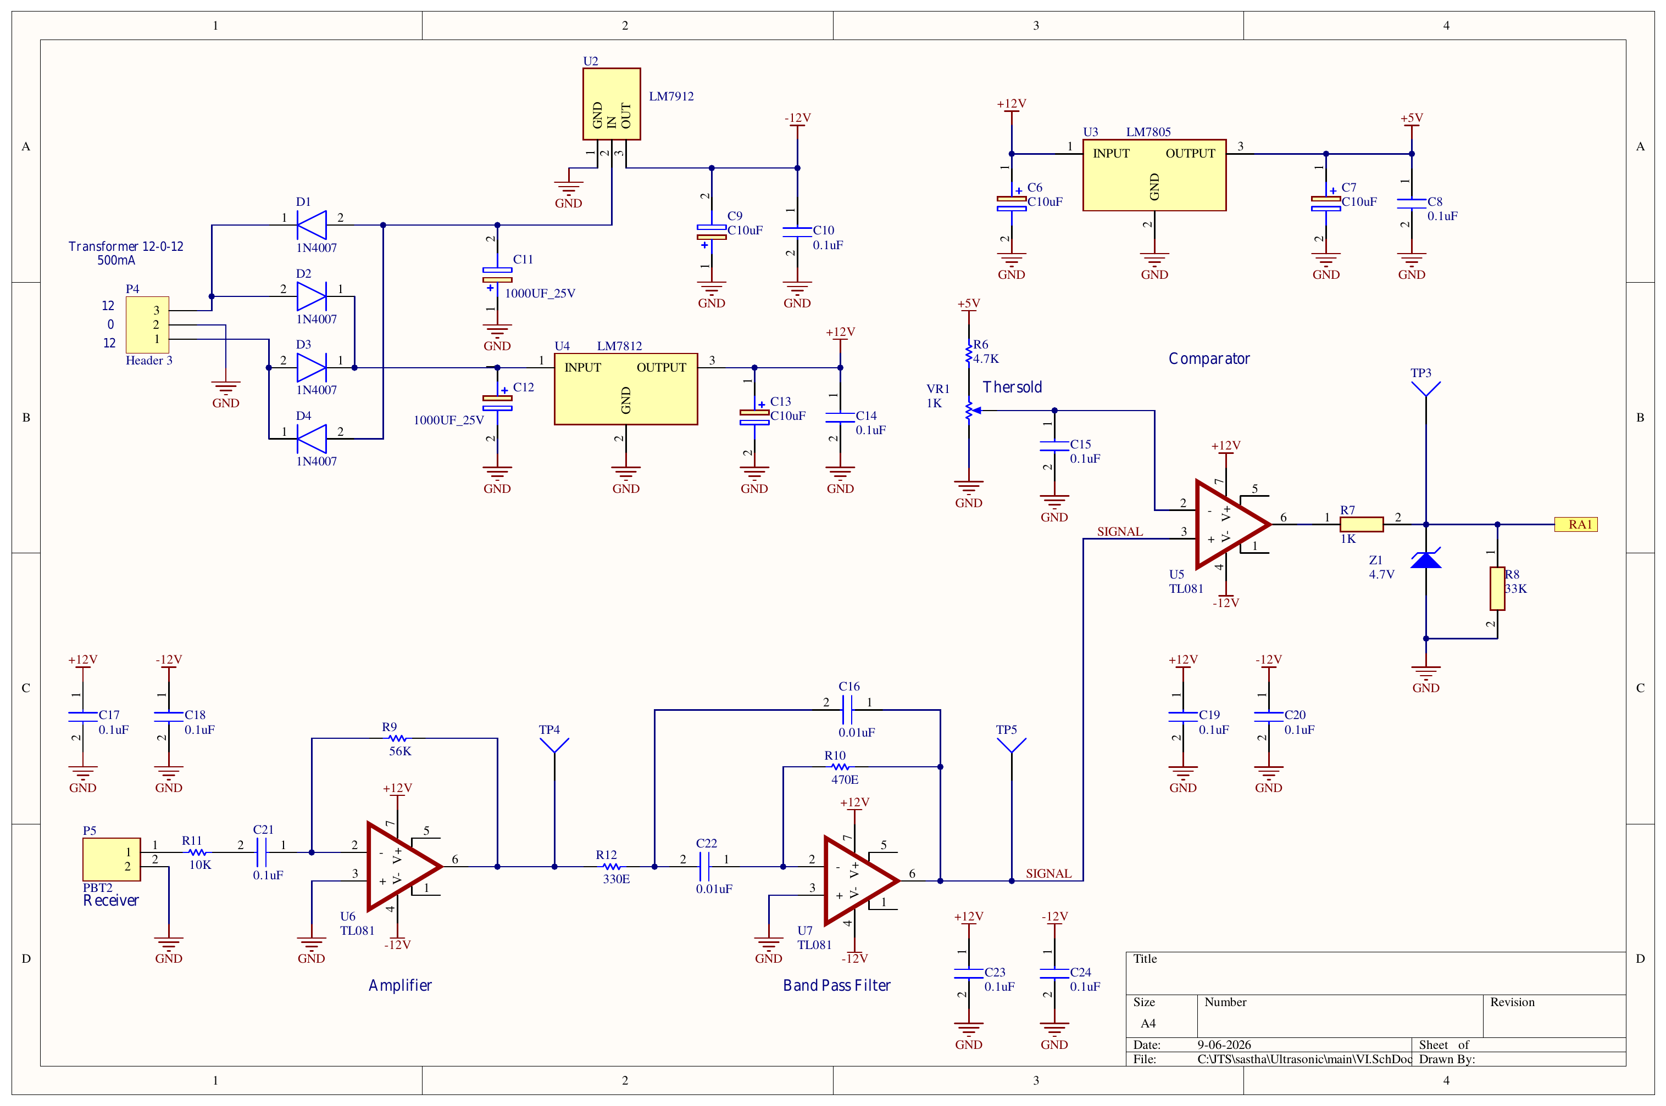
Figure F3 - VI.SchDoc: the power supply and the complete receive chain - pre-amplifier U6, band-pass filter U7 and comparator U5. TP3, TP4 and TP5 are on this sheet.

